

How to import Bravo NGS protocol files

on Windows 10 (64 – bit) PC using VWorks Software13.1



November 29, 2019

MPI Leipzig

Contents

1. How to import single strand library preparation protocol files 1

2. How to import qPCR setup preparation protocol files 16

3. How to import indexing primer aliquot plates preparation protocol files 27

4. How to import 96_ssDNAprep_indexingPCR_setup protocol files 42

5. How to import SPRI beads purification protocol files 56

5.1 Bravo 96 format 28% SPRI purification 56

5.2 Bravo 384 format 28% SPRI purification 69

6. How to import Capture setup protocols 70

6.1 Re amplification setup for capture of 96 libraries 70

6.2 Re amplification setup for capture of 384 libraries 71

6.3 Preparation for capture plate setup 72

6.3.1 Transfer libraries from 96-well plate to 96-well plate 72

6.3.2 Transfer libraries from 96-well plate to 384-well plate 73

6.3.3 Transfer Baits from 5ml tubes to 384-well plate 74

6.4 In solution capture preparation 75

6.4.1 In solution Hybridization setup for 96 samples 75

6.4.2 In solution capture clean-up for 96 samples 76

6.4.3 In solution Hybridization setup for 384 samples 77

6.4.4 In solution capture clean-up for 384 samples 78

6.4.4.1 In solution capture clean-up for 384 samples using 96 LT head < Part 1> 78

6.4.4.2 In solution capture clean-up for 384 samples using 384 ST head < Part 2> 79

6.5 On bead capture preparation 80

6.5.1 On bead Hybridization setup for 96 samples 80

6.5.2 On bead capture clean-up for 96 samples 81

6.5.3 On bead Hybridization setup for 384 samples 82

6.5.4 On bead capture clean-up for 384 samples 83

6.6 Post capture preparation 84

6.6.1 Libraries pool for sequencing preparation for 96 libraries 84

6.6.2 Libraries pool for sequencing preparation for 384 libraries 85

## 1. How to import single strand library preparation protocol files

**Files needed:**

1. VWork software version 13.1.0.1366
2. Device file: Bravo4,6-RedInserts.dev
3. Bravo profile is: Bravo4,6-RedInserts
4. Form file: 96_ssDNAprep.VWForm

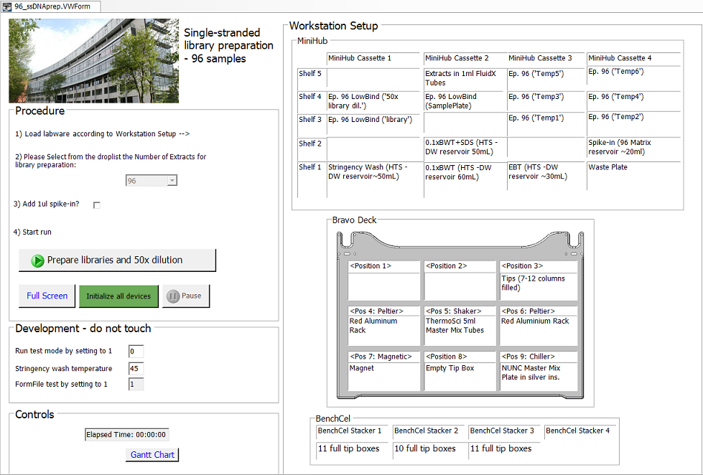

1. Runset file: ssDNAprep_96samples_lib_prep_and_dilutions.rst
2. Protocol files:
   1. ssDNAprep_96samples_A1_transfer_master_mixes.pro
   2. ssDNAprep_96samples_A2_transfer_extracts.pro
   3. ssDNAprep_96samples_B_dephosphorylation.pro
   4. ssDNAprep_96samples_C_ligation_preparation.pro
   5. ssDNAprep_96samples_D_ligation.pro
   6. ssDNAprep_96samples_E_bead-binding.pro
   7. ssDNAprep_96samples_F_post_binding_washes.pro
   8. ssDNAprep_96samples_G_fill-in_preparation.pro
   9. ssDNAprep_96samples_H_fill-in.pro
   10. ssDNAprep_96samples_I_post-fill-in-washes.pro
   11. ssDNAprep_96samples_J_2nd-ligation.pro
   12. ssDNAprep_96samples_K_post-ligation-washes.pro
   13. ssDNAprep_96samples_L_elution.pro
   14. ssDNAprep_96samples_M_dispenseEBT.pro
   15. ssDNAprep_96samples_N_qPCR-dilutions.pro
3. Labware editor:

* 24-96 ThermoScientific 5ml
* 96 format fluidx 1ml tubes
* 96 Matrix open reservoir movable
* 96 Ay Deep-well HTS reservoir
* 96 Deep Well PP Sqr Well V Btm
* 96 Nunc Deep Well 1 mL using Silver Insert
* 96 Eppendorf Twin.tec PCR
* 96 V11 LT250 Tip Box 19477.002

1. Liquid classes:

* 96 disposable tip 2 - 50ul
* MM_LigMix1
* 96 disposable tip 11 ul- 50ul
* MM_BeadBinding_ssDNA
* Bead Mixing
* 96 disposable tip 1 - 2ul
* MM_dispenseWait5min
* Buffer 2 mix
* 96 disposable tip 50 - 180ul aq
* Ethanol to waste
* MM_38SPRI
* MM_PEG8000
* 96 disposable tip 2 - 10ul aq
* 96 disposable tip 10 - 50ul aq
* dispense then long wait

1. Pipetting techniques:

* 60W
* 60S

**Procedure:**

1. Start the VWorks software and login as administrator. Navigate to the File tab and click Import:

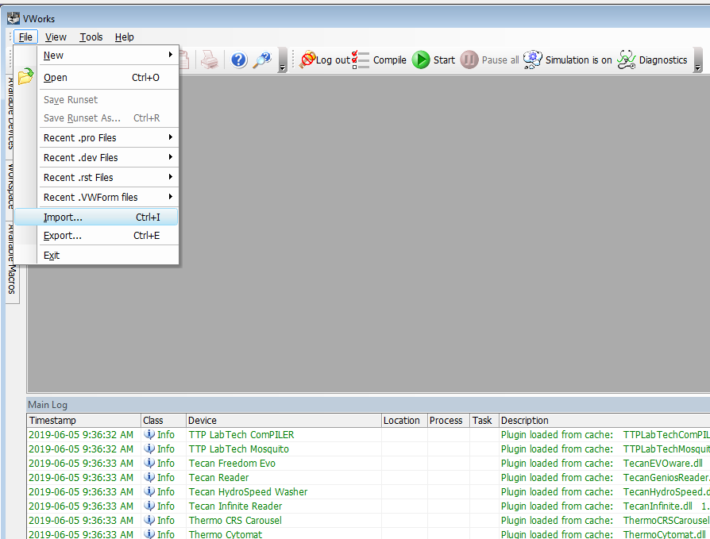

1. It is advisable to save a backup before importing anything by selecting 🡪 Yes

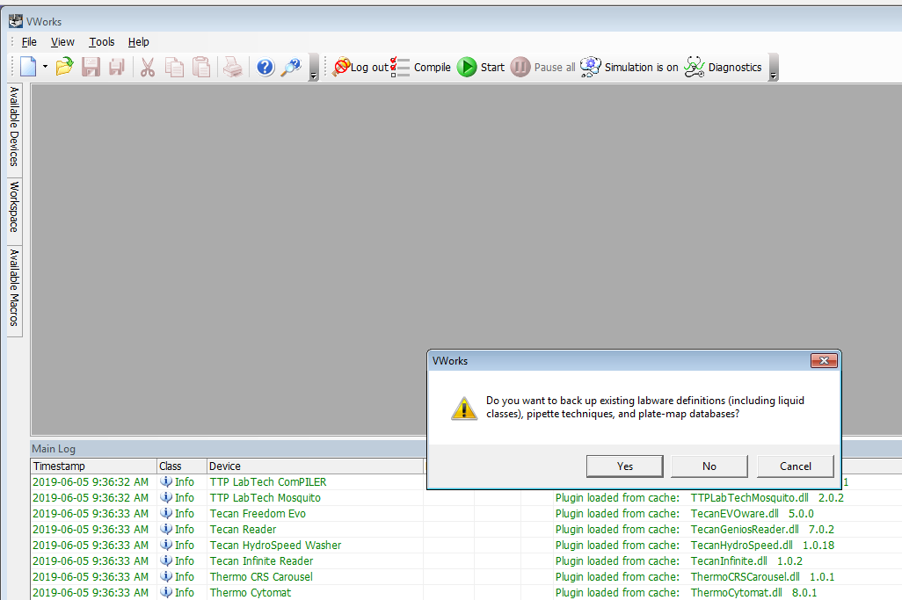

1. Select the file to import: SingleStrandedLibrPrep.vzp 🡪 Next

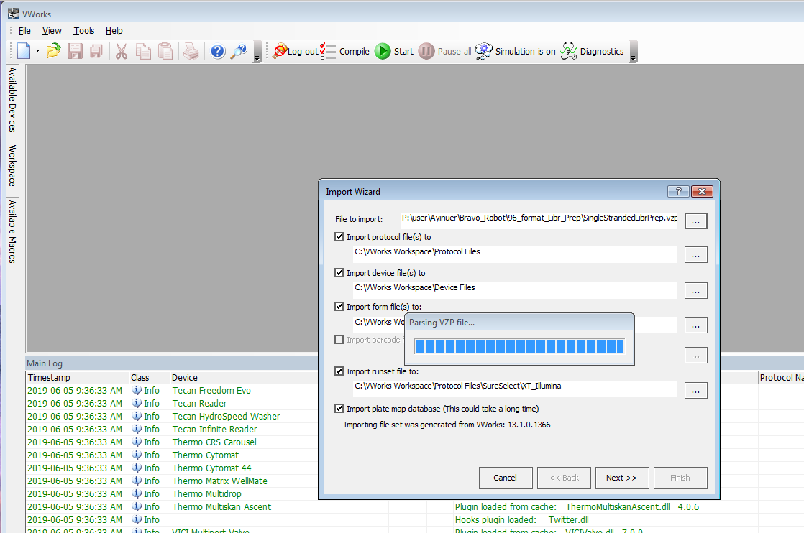

1. Select the desired location for device files and protocol files as well as for the runset files. 🡪 Next

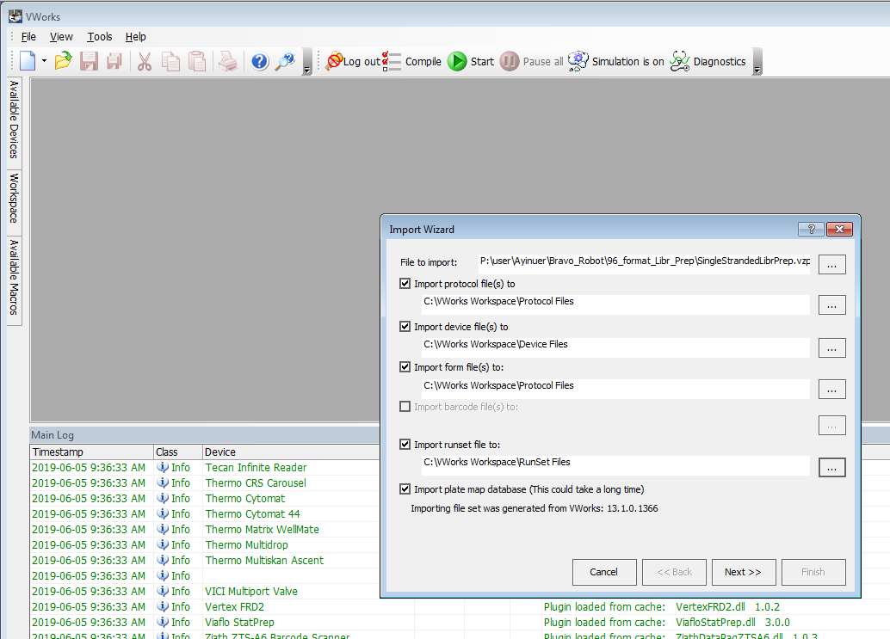

1. Confirm the final location for each file type. 🡪 OK

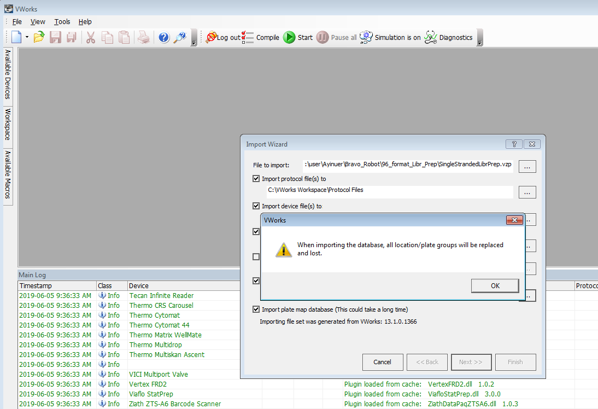

1. Below is the list of customer labware entries. 🡪 Import labware entries not known to this system **>>**.

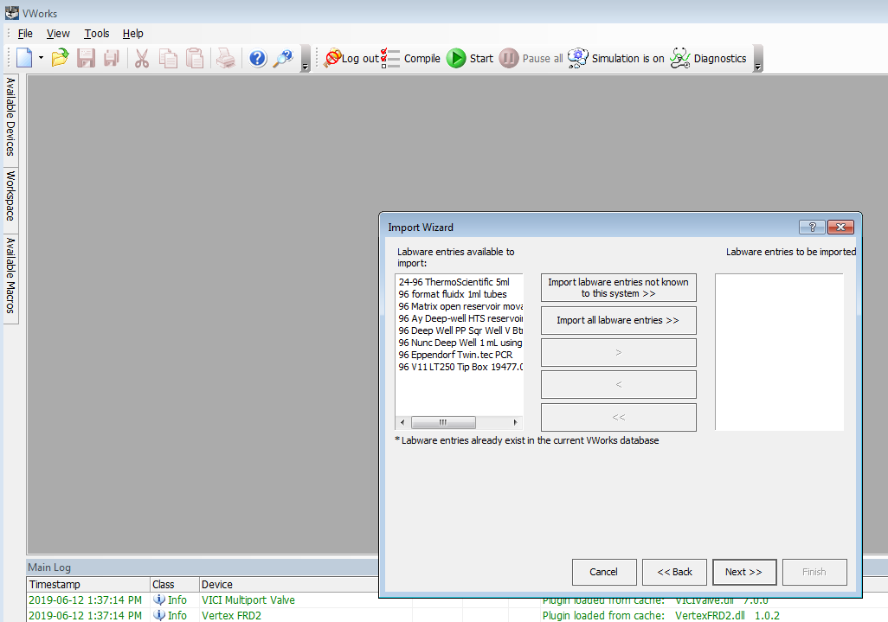

1. Next 🡪

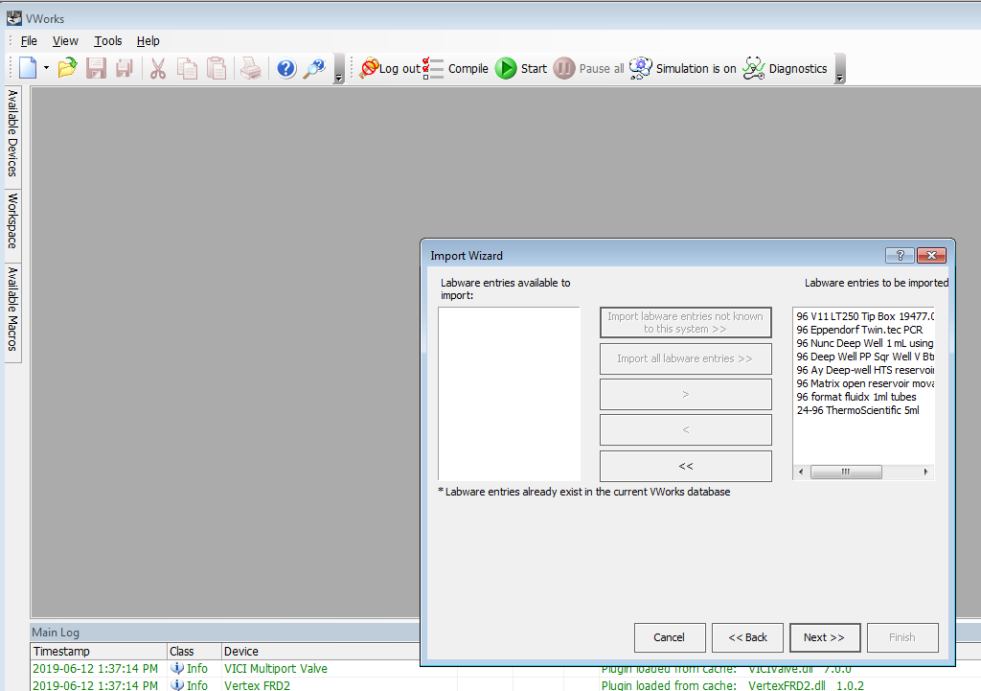

1. Next 🡪

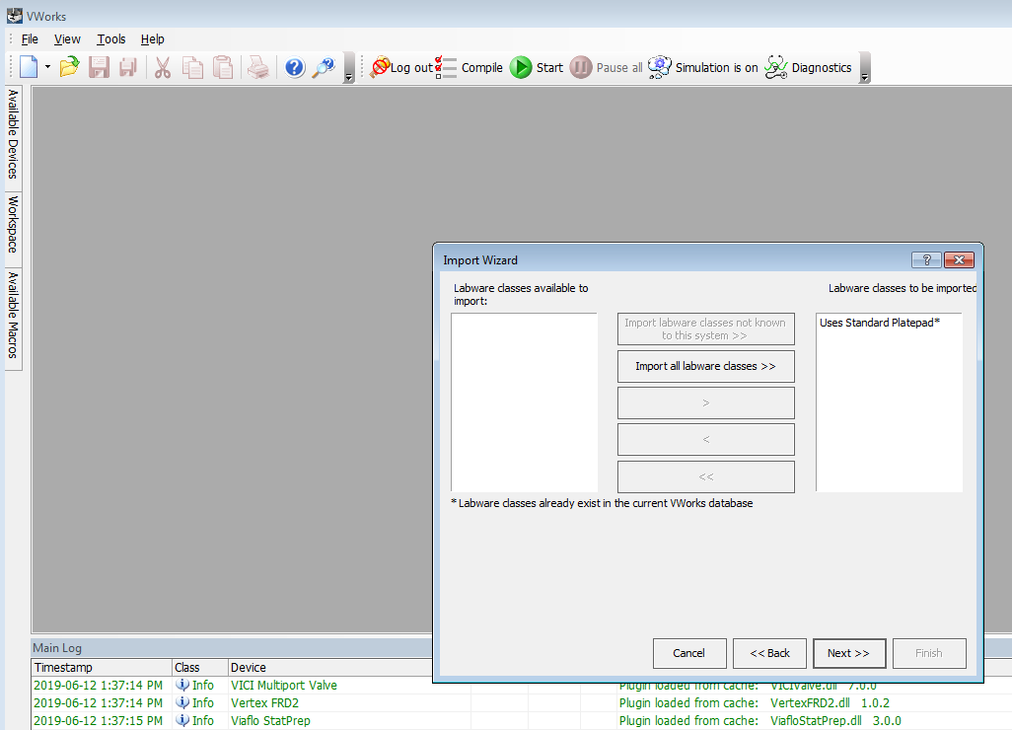

1. Check continue and append new labware entries to the labware class – The labware class will contain both new and existing labware entries. 🡪 OK

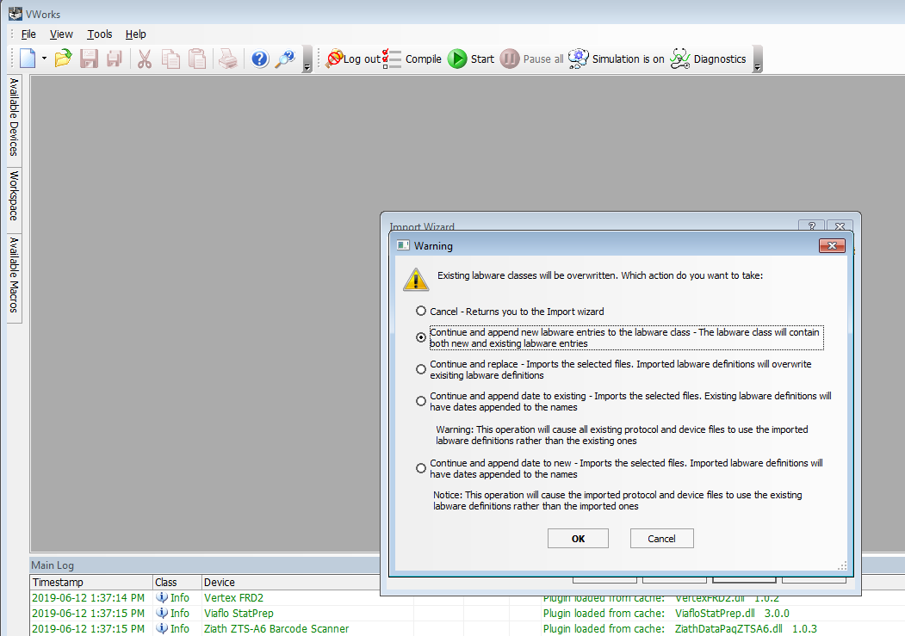

1. Below is the list of customer liquid classes. 🡪 Import liquid classes not known to this system **>>**.

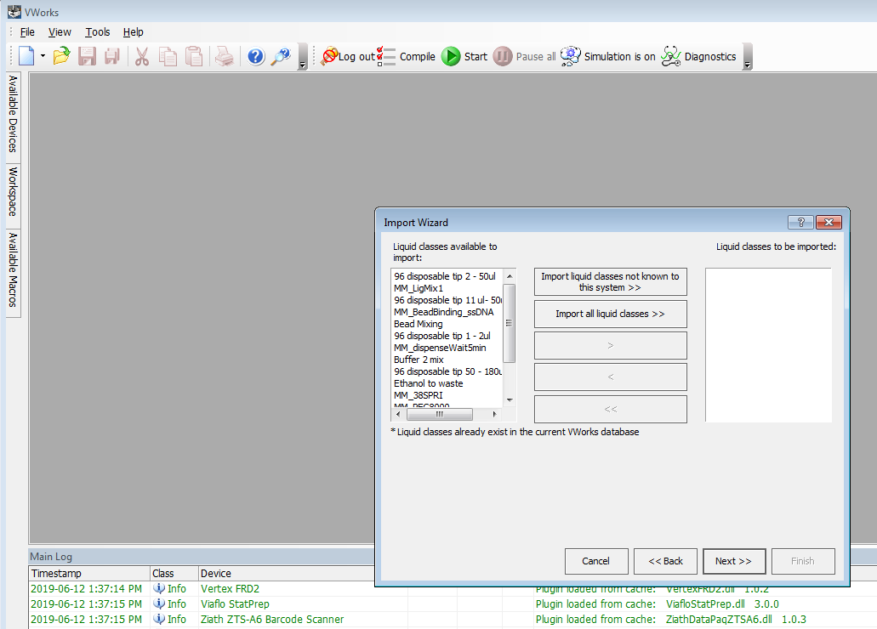

1. Next

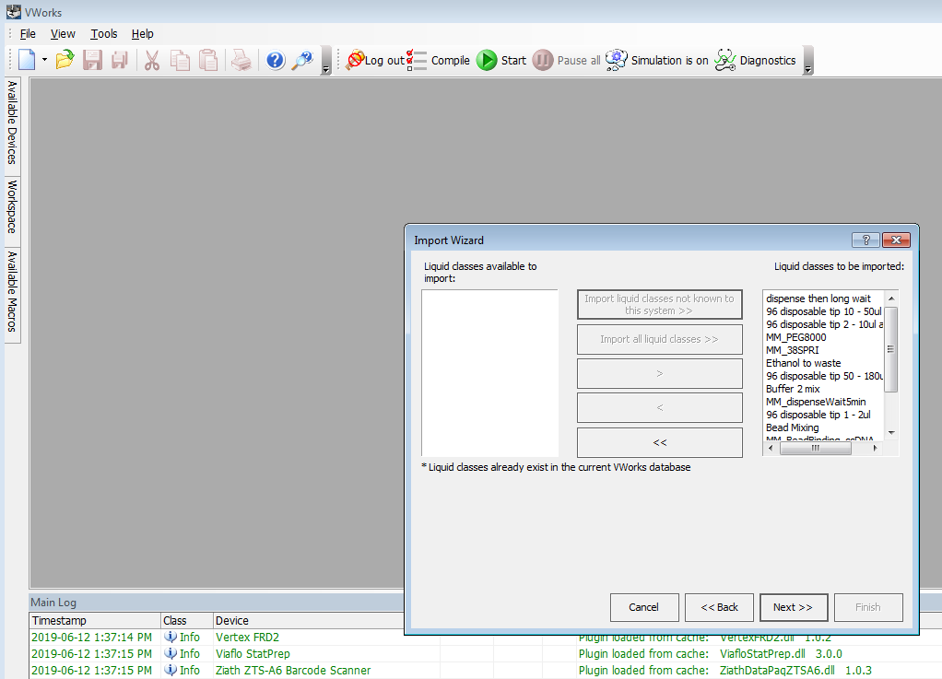

1. Below is the list of customer pipette techniques. 🡪 Import pipette techniques not known to this system.

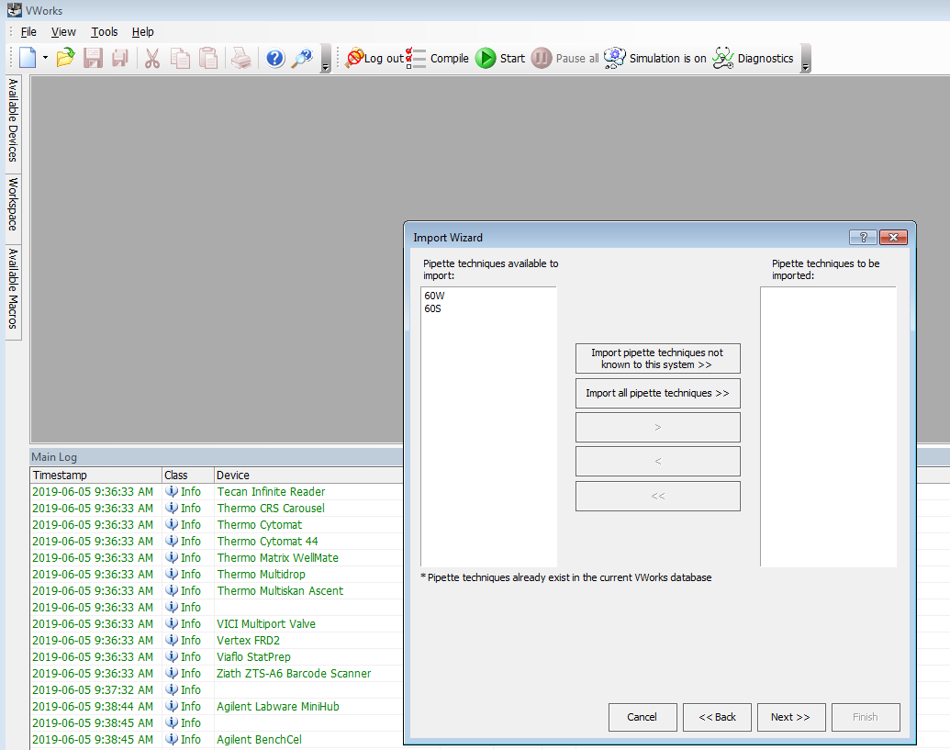

1. Next 🡪

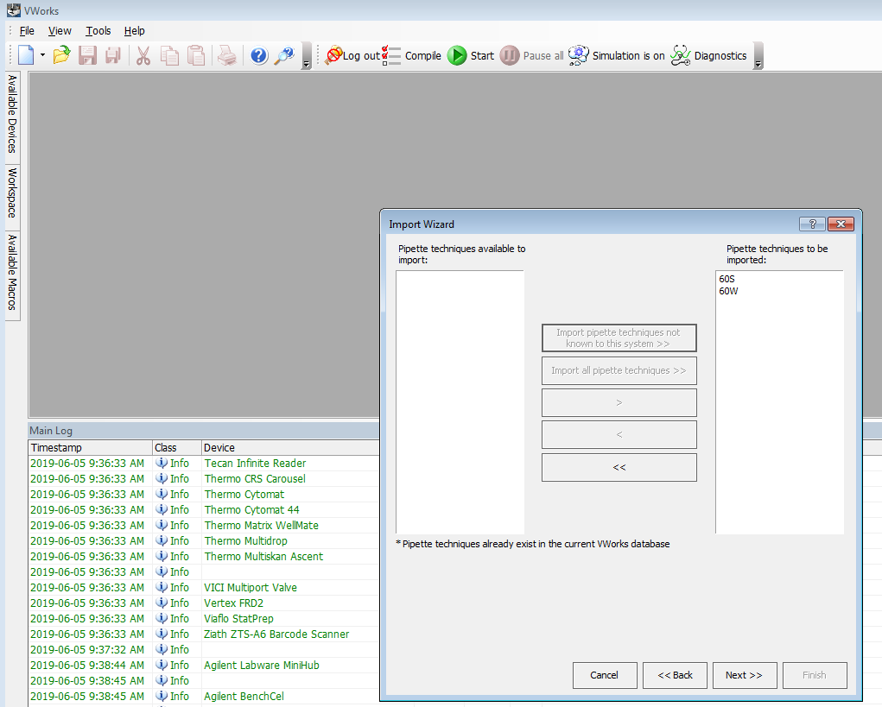

1. **Extremely important!** Device profiles 🡪 Import device profiles not known to this system. Be aware that you might have different teach points for each device. You may need to fine tune the teach points per Bravo profile.

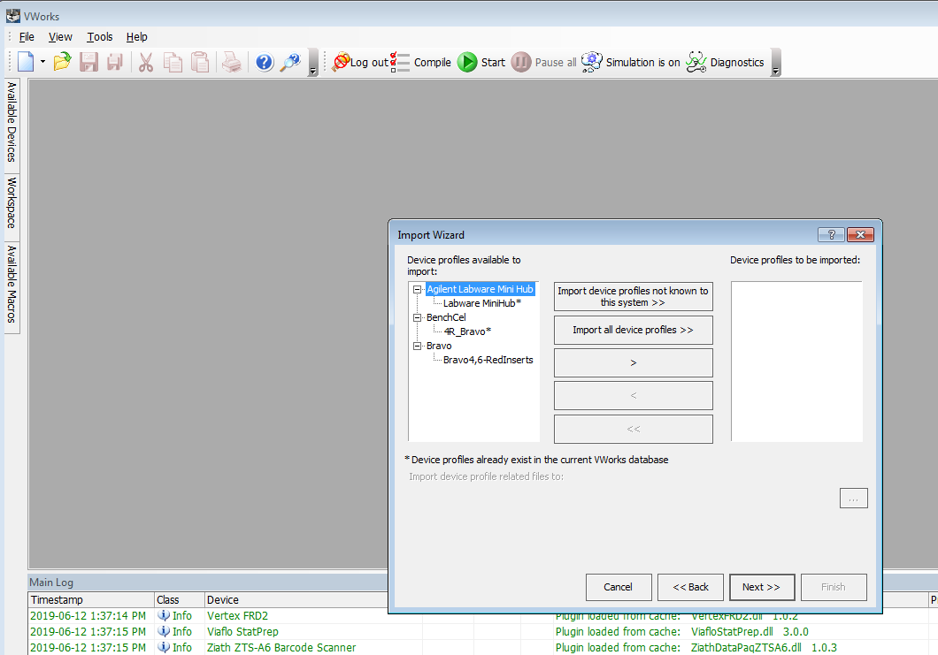

1. Next 🡪

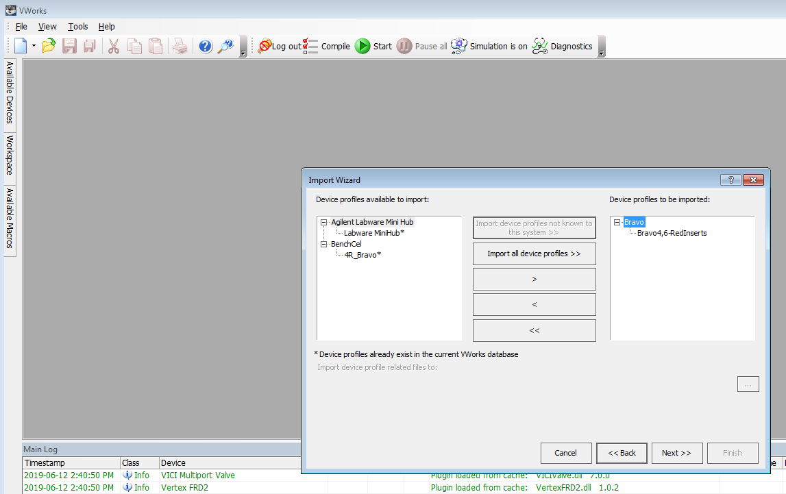

1. Error handlers. You do not have to import error handlers. 🡪 Next

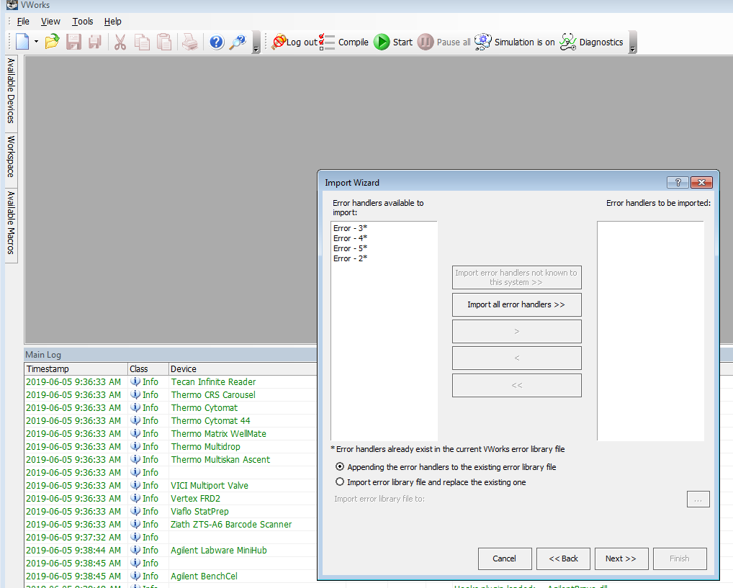

1. Attached files for pipette techniques click **>>** then 🡪 Next

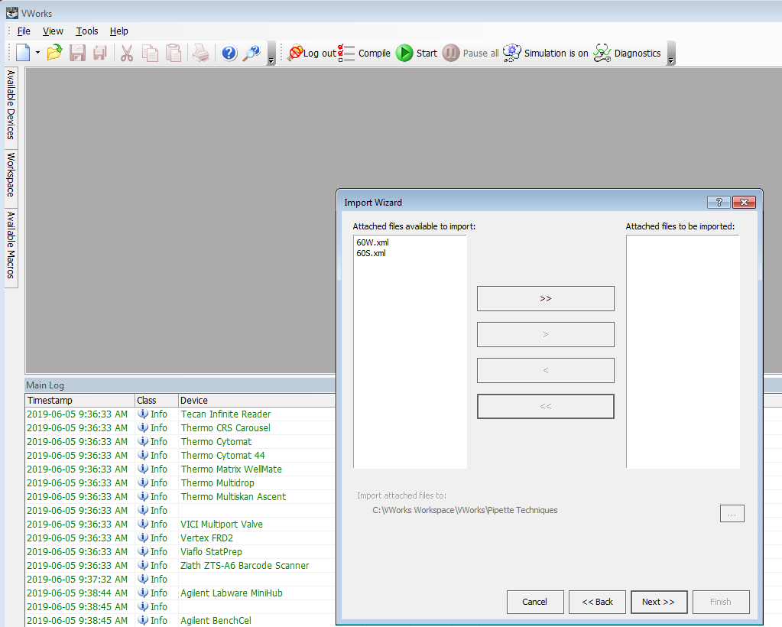

1. Import location for pipette techniques should be C:\VWorks Workspace\VWorks\Pipette Techniques. 🡪 Next

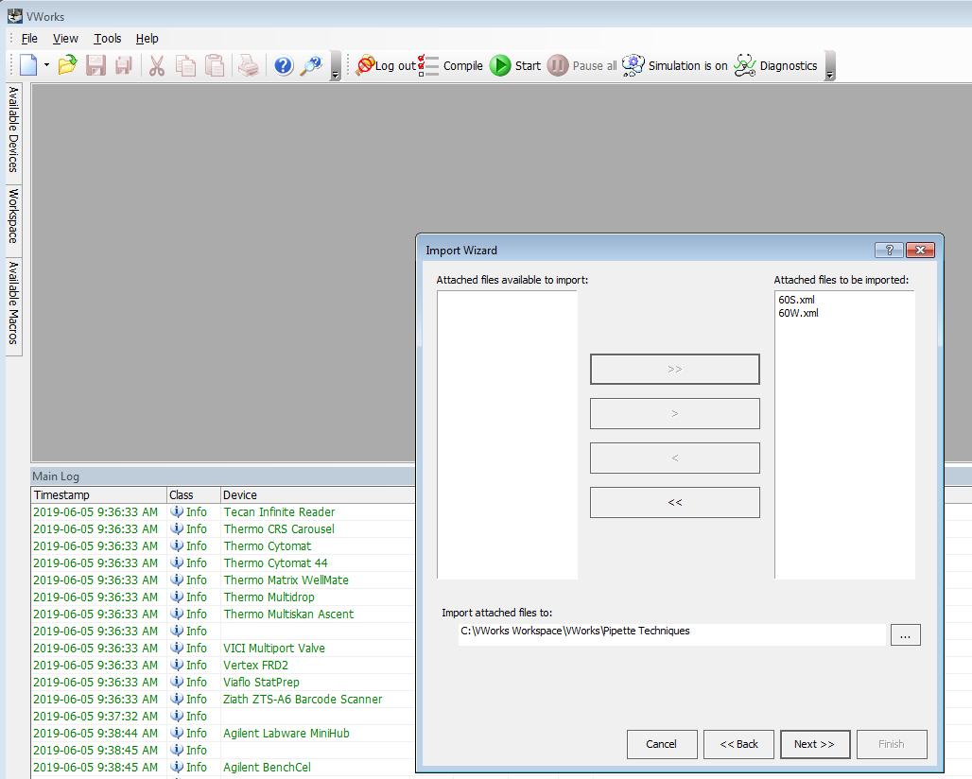

1. Double check the summary of the import files. 🡪 Finish!

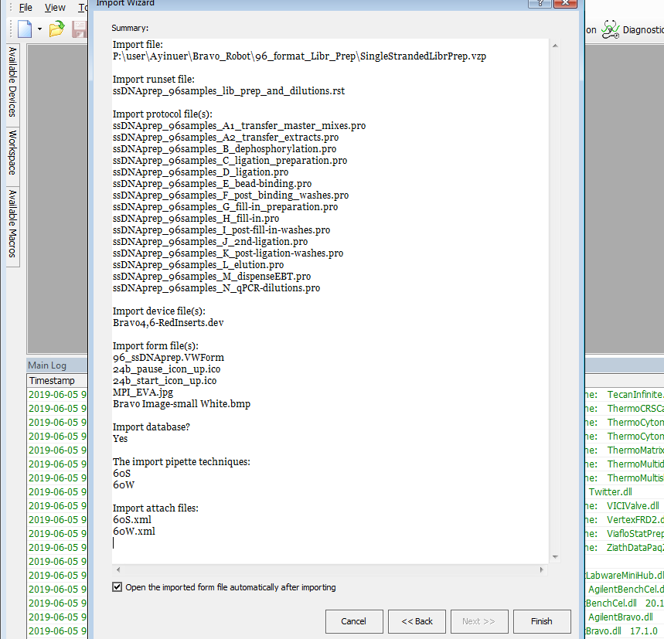

1. Once the import wizard completes, the 96_ssDNAprep.VWForm will pop up. Go to Tools select Edit Form as pictured below:

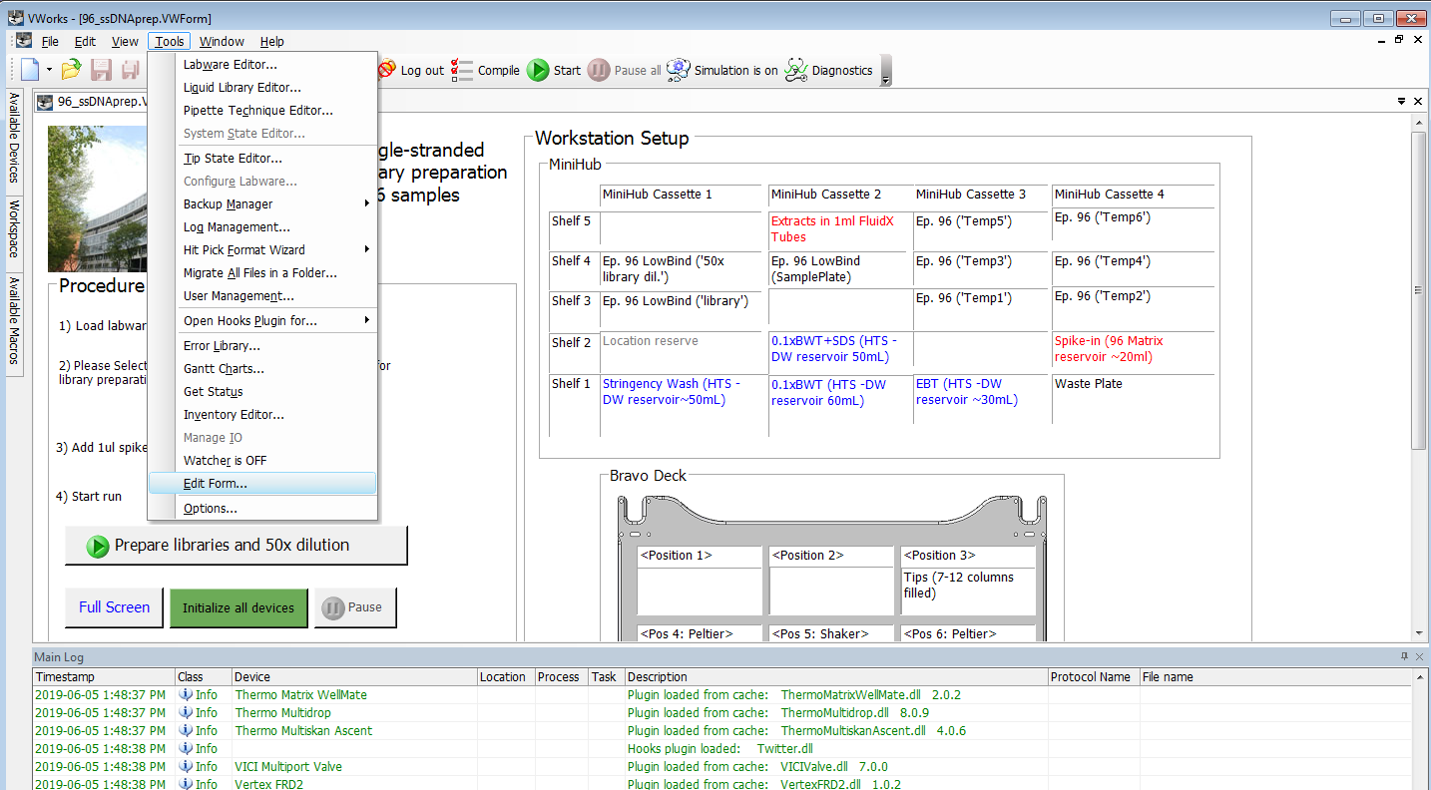

1. If you click the “Prepare libraries and 50X dilution”, you will see the path to the Runset file. You must provide the correct location of the Runset file!

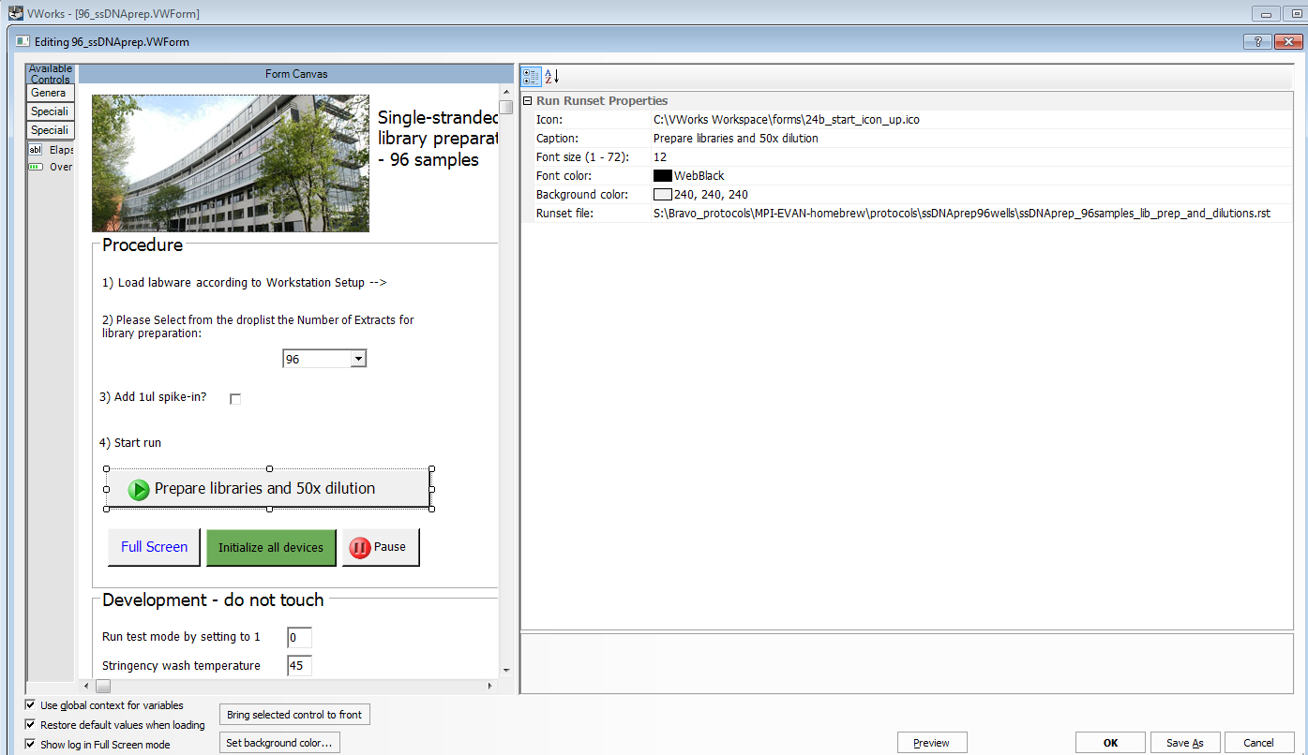

1. If you click “initialize all devices”, you will see the path to the Device file. You must provide the correct location of the device file!

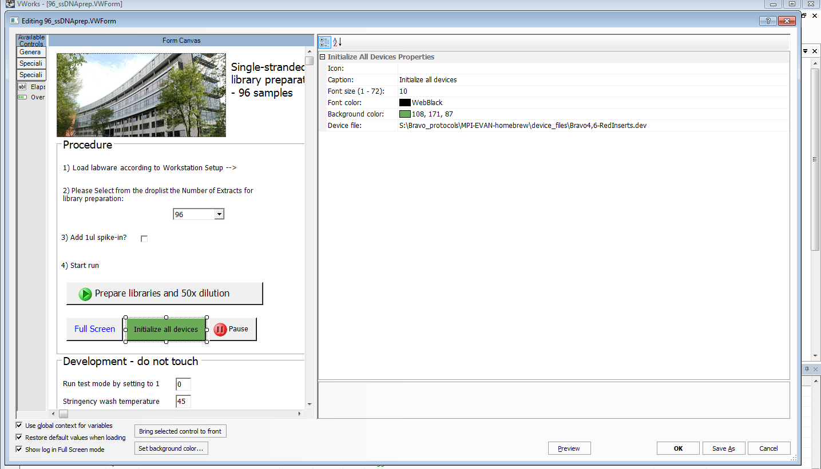

1. Once you are done with importing the files successfully, you may try to initialize all devices. If the orbital shaker of your device has different serial port number than the imported device profile file, you can adjust it easily in the registry editor as attached picture below.

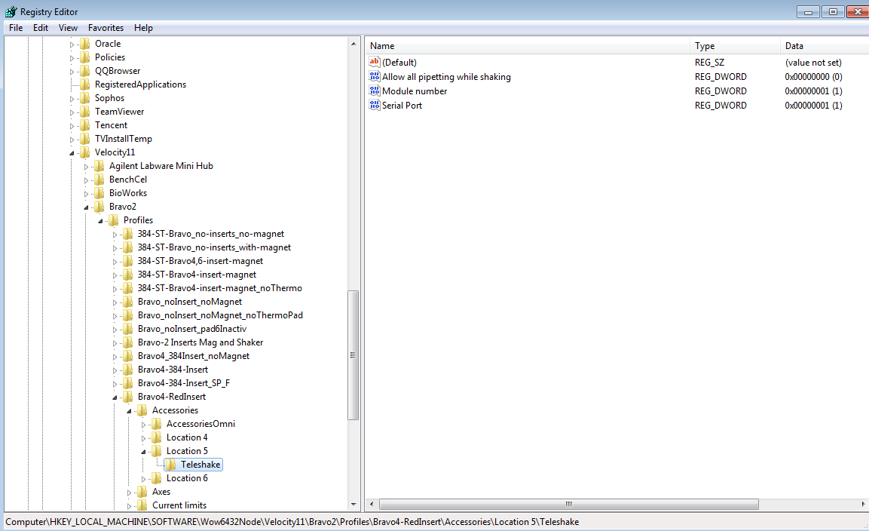

## 2. How to import qPCR setup preparation protocol files

**Files needed:**

1. VWork software version 13.1.0.1366
2. Device file: BravoMiniPHBenchCel_round_magnet_noThermoPad.dev
3. Bravo device profile is: Bravo-Mag and Shaker_noThermoPad
4. Form file: 96_ssDNAprep_qPCR_setup.VWForm

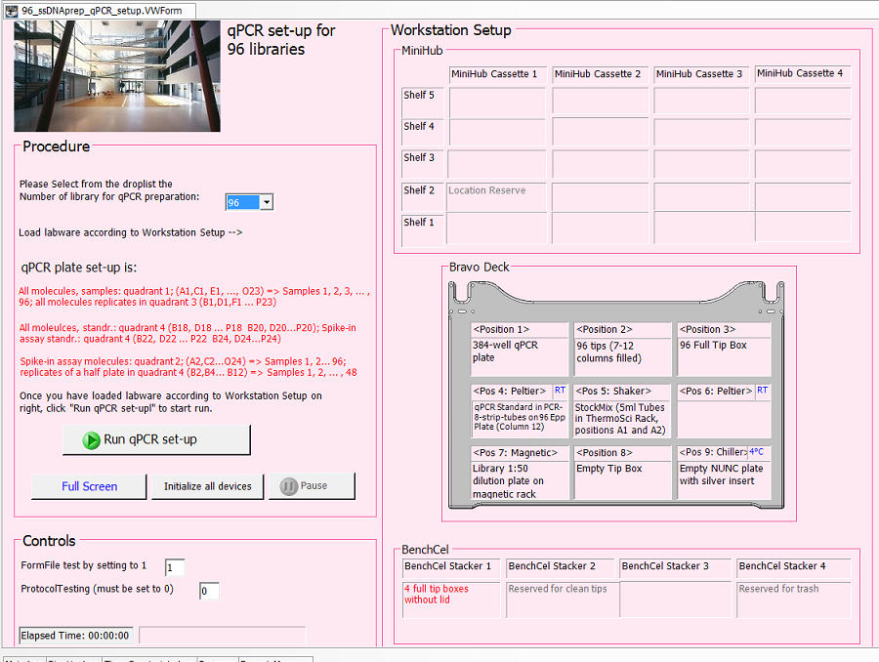

1. Runset file: ssDNAprep_96samples_lib_qPCR.rst
2. Protocol files:
   1. ssDNAprep_96samples_Q_qPCR_1_PreMixing.pro
   2. ssDNAprep_96samples_Q_qPCR_2_Prep.pro
3. Labware editor:

* 96 V11 LT250 Tip Box 19477.002
* 24-96 ThermoScientific 5ml
* PCRTubeStrips in black carrier
* 96 Nunc Deep Well 1 mL using Silver Insert
* 96 Eppendorf Twin.tec PCR
* 384 BioRad Hard Shell
* 384 Ay BioRad Hard Shell clear wells

1. Liquid classes:

* 96 disposable tip 2 - 10ul aq
* 96 disposable tip 50 - 180ul aq
* MM_PEG8000
* MM_38SPRI
* 96 disposable tip 1 - 2ul
* 96 disposable tip 2 - 50ul
* 96 disposable tip 10 - 50ul aq

**Procedure:**

1. Start the VWorks software and login as administrator. Navigate to the File tab and click Import:



1. It is advisable to save a backup before importing anything by selecting 🡪 Yes



1. Select the file to import: *96_ssDNAprep_qPCR_setup.vzp* and select the desired location for device files and protocol files as well as for the runset files. 🡪 Next

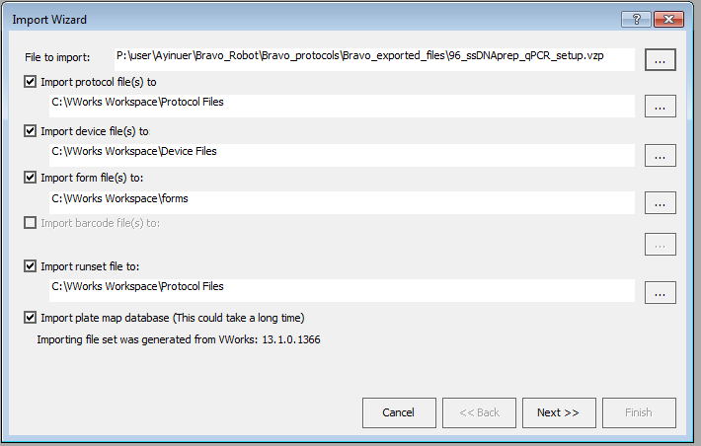

1. Confirm the final location for each file type. 🡪 OK

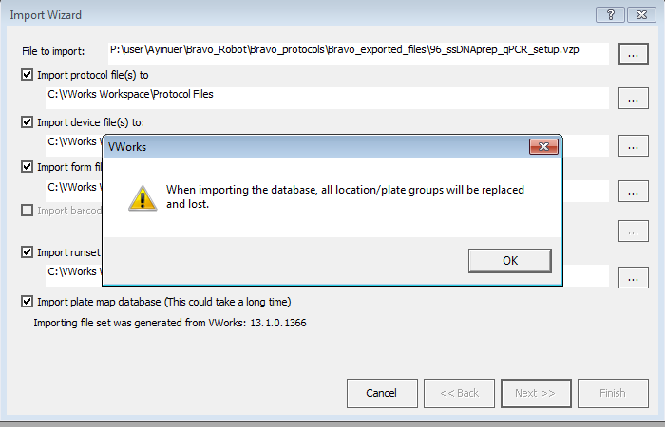

1. Below is the list of customer labware entries. 🡪 Import labware entries not known to this system **>>**.

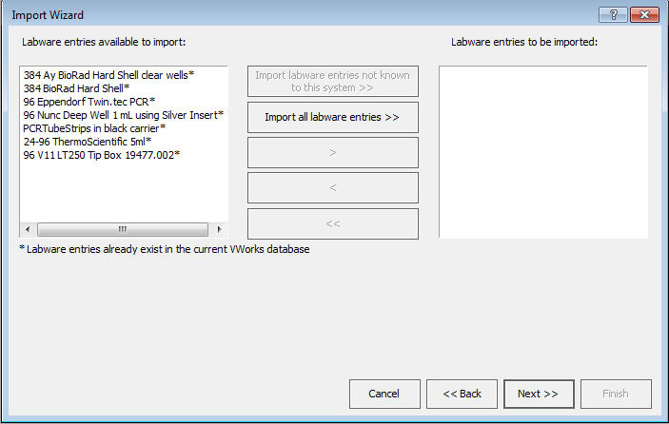

1. Next 🡪

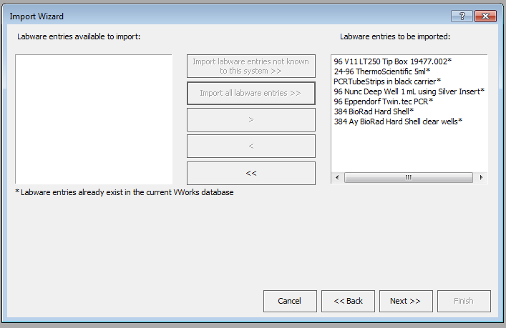

1. Next 🡪



1. Check continue and append new labware entries to the labware class – The labware class will contain both new and existing labware entries. 🡪 OK



1. Below is the list of customer liquid classes. 🡪 Import liquid classes not known to this system **>>**.

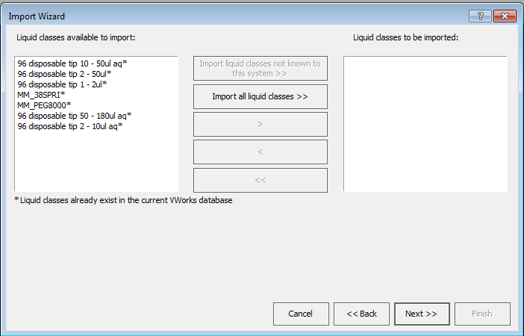

1. Next

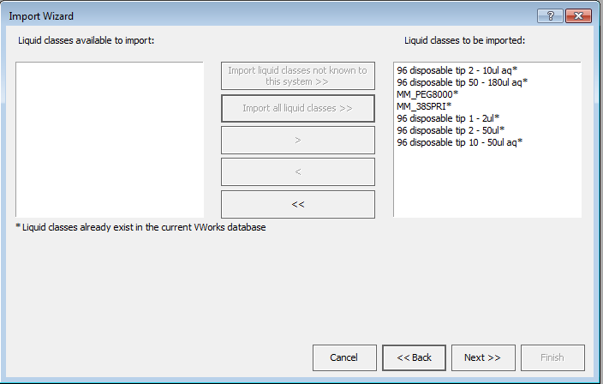

1. **Extremely important!** Device profiles 🡪 Import device profiles not known to this system. Be aware that you might have different teach points for each device. You may need to fine tune the teach points per Bravo profile.

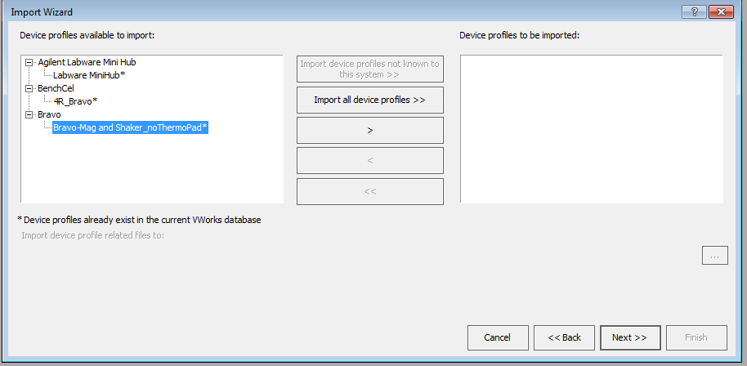

1. Next 🡪

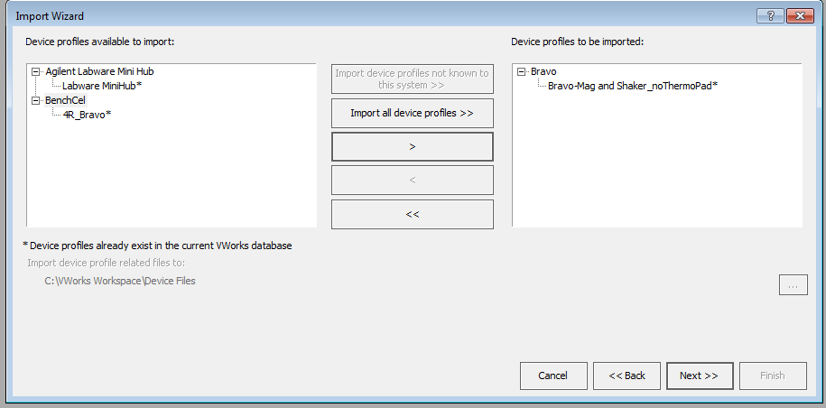

1. Double check the summary of the import files. 🡪 Finish!

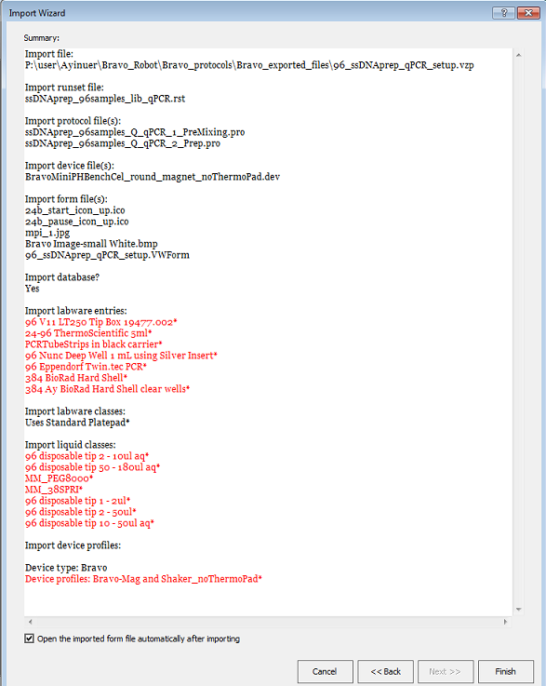

1. Once the import wizard completes, the Form file will pop up. Go to Tools select Edit Form as pictured below:

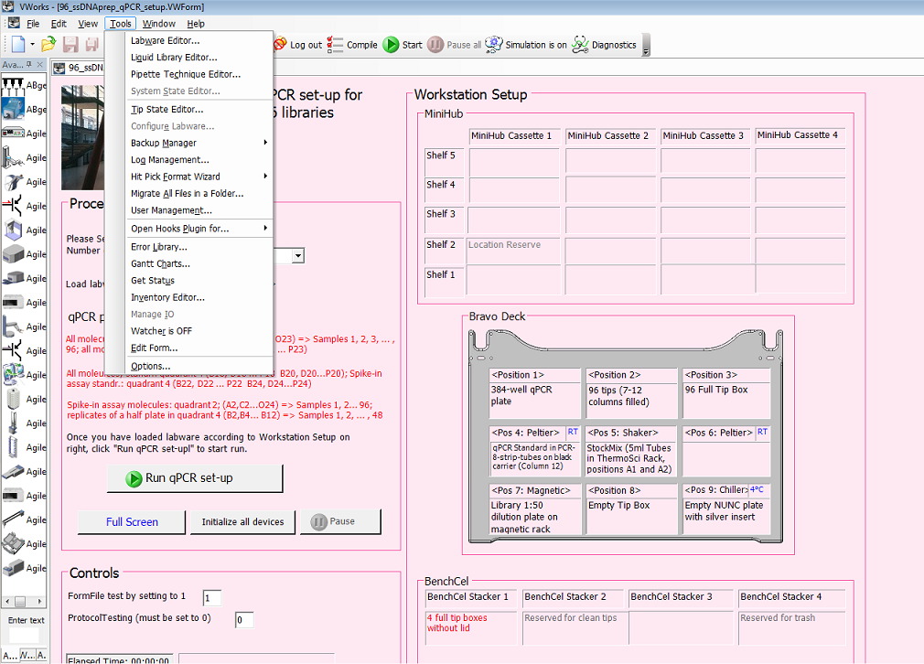

1. If you click the “Run qPCR set-up”, you will see the path to the Runset file. You must provide the correct location of the Runset file!

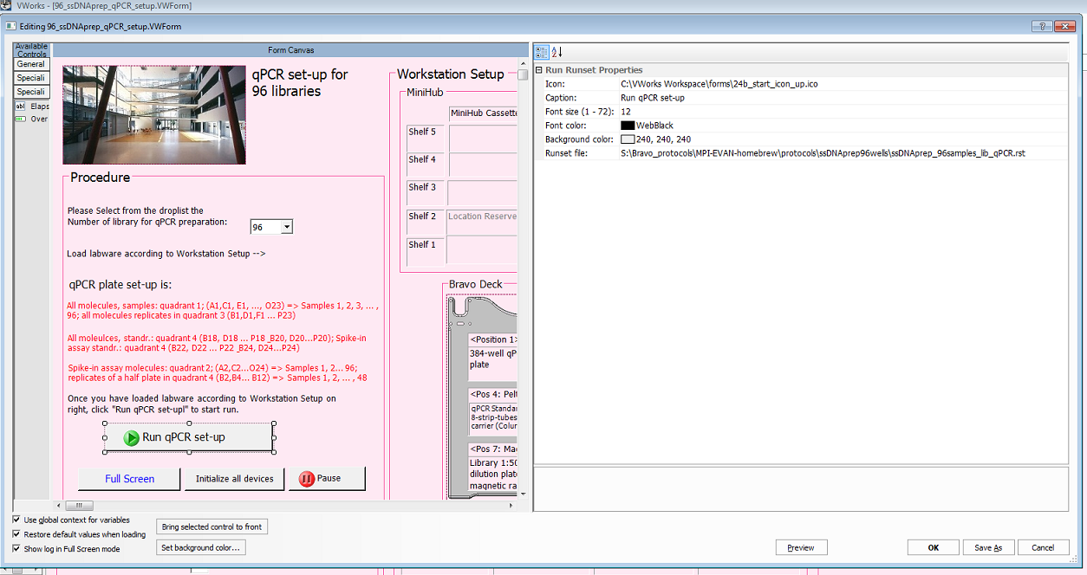

1. If you click “initialize all devices”, you will see the path to the Device file. You must provide the correct location of the device file!

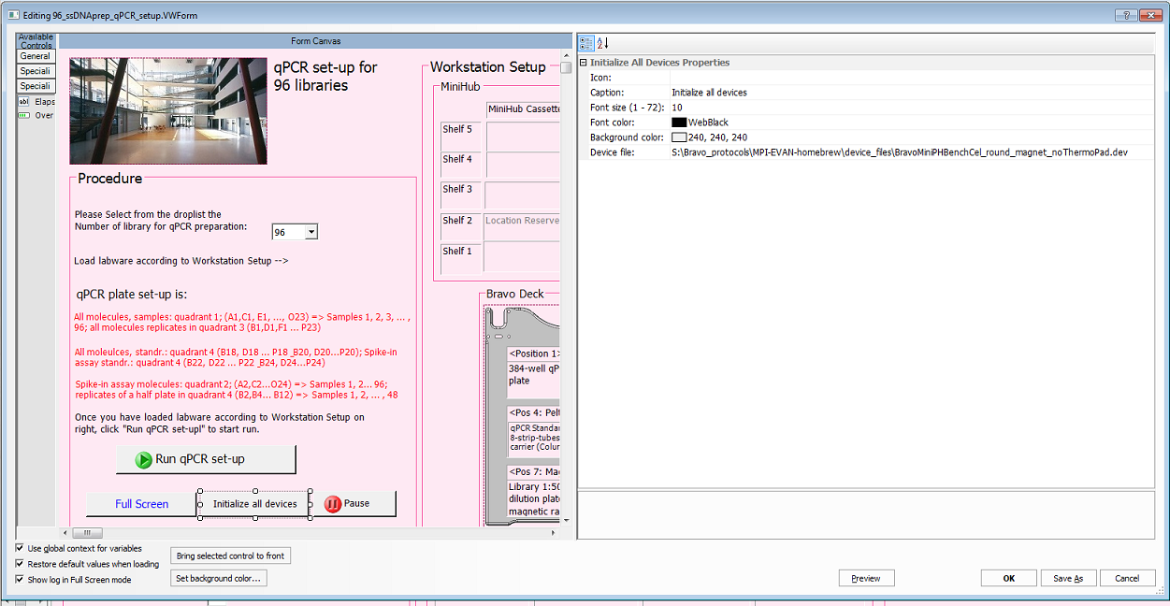

1. Once you are done with importing the files successfully, you may try to initialize all devices. If the orbital shaker of your device has different serial port number than the imported device profile file, you can adjust it easily in the registry editor as attached picture below.



## 3. How to import indexing primer aliquot plates preparation protocol files

**Files needed:**

1. VWork software version 13.1.0.1366
2. Device file: Ay_Bravo_no_Inserts_noMagnet.dev
3. Bravo profile is: Bravo_noInsert_noMagnet
4. Form file: the indexing primer aliquot plates preparation contains two form files and it has to be imported separately and has to be run one after another.

### Part1_Aliquot_Stock_indices_96NuncPlate.VWForm

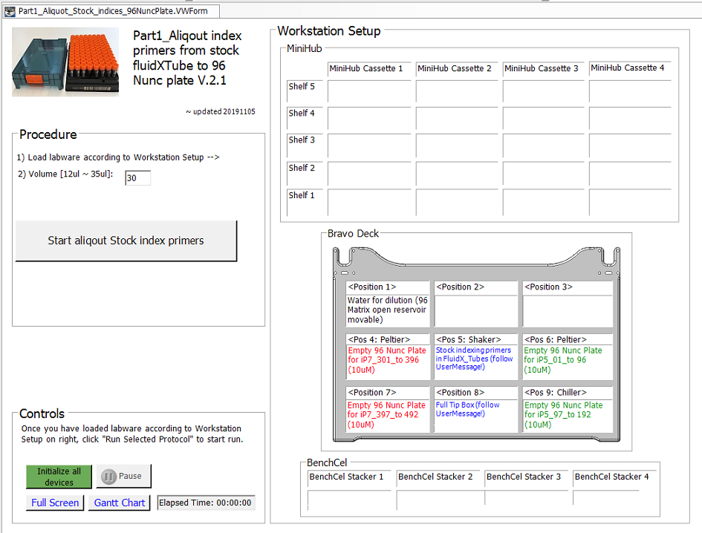

### Part2_Aliquot_indices_384wellPlate.VWForm

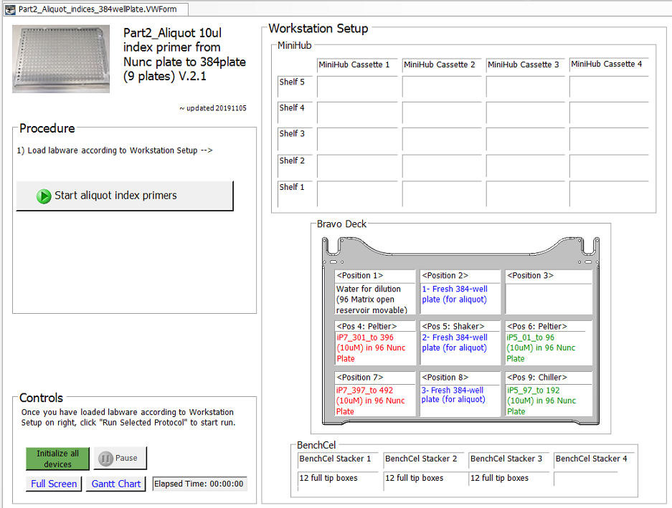

1. Runset file:
   * + 1. aliqout_indices_toNuncPlate.rst
       2. aliqout_indices_to9Plates.rst
2. Protocol files:
   1. Aliqout_indices_FdX_to_96Nunc_Plate_A.pro
   2. Aliqout_indices_FdX_to_96Nunc_Plate_B.pro
   3. Aliqout_indices_FdX_to_Plate1.pro
   4. Aliqout_indices_FdX_to_Plate2.pro
   5. Aliqout_indices_FdX_to_Plate3.pro
   6. Aliqout_indices_FdX_to_Plate4.pro
   7. Aliqout_indices_FdX_to_Plate5.pro
   8. Aliqout_indices_FdX_to_Plate6.pro
   9. Aliqout_indices_FdX_to_Plate7.pro
   10. Aliqout_indices_FdX_to_Plate8.pro
   11. Aliqout_indices_FdX_to_Plate9.pro
3. Labware editor:

* 96 format fluidx 1ml tubes
* 96 Matrix open reservoir movable
* 96 Nunc Deep Well 1 mL using Silver Insert
* 384 BioRad Hard Shell or 384 Eppendorf Twin.tec PCR
* 96 V11 LT250 Tip Box 19477.002

1. Liquid classes:

* Buffer 2 mix
* Ay_38SPRI
* MM_PEG8000
* 96 disposable tip 2 - 10ul aq

**Procedure:**

1. Start the VWorks software and login as administrator. Navigate to the File tab and click Import:



1. It is advisable to save a backup before importing anything by selecting 🡪 Yes



1. Select the file to import: *Aliquot_indices_part1.vzp* and select the desired location for device files and protocol files as well as for the runset files. 🡪 Next

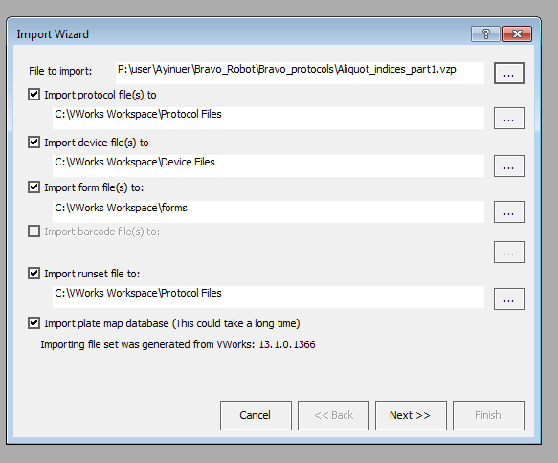

1. Confirm the final location for each file type. 🡪 OK

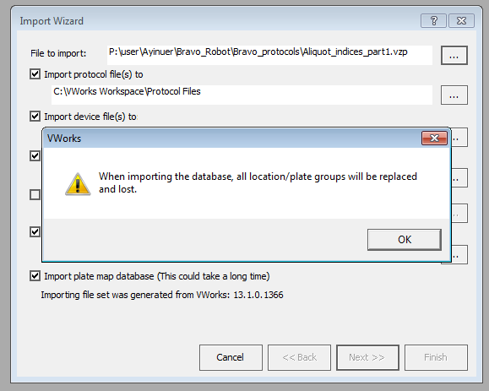

1. Below is the list of customer labware entries. 🡪 Import labware entries not known to this system **>>**.

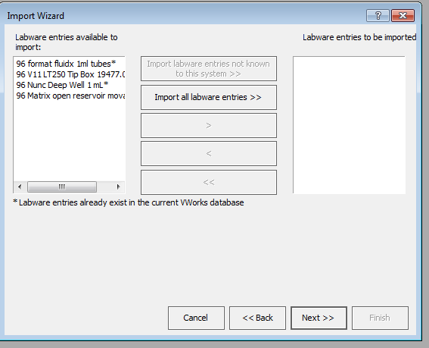

1. Next 🡪

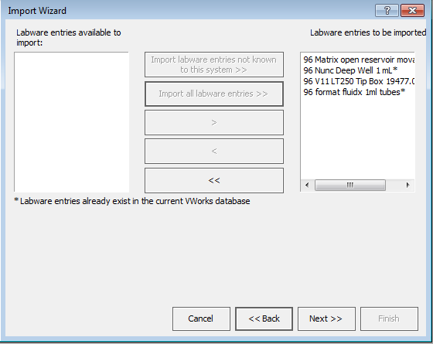

1. Next 🡪



1. Check continue and append new labware entries to the labware class – The labware class will contain both new and existing labware entries. 🡪 OK



1. Below is the list of customer liquid classes. 🡪 Import liquid classes not known to this system **>>**.

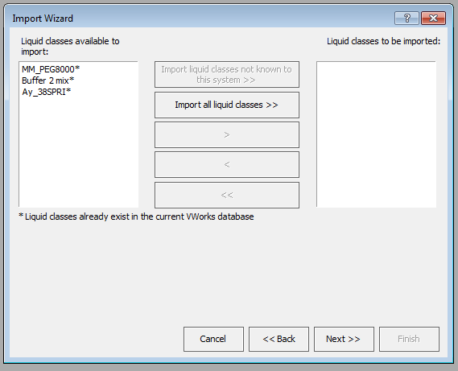

1. Next

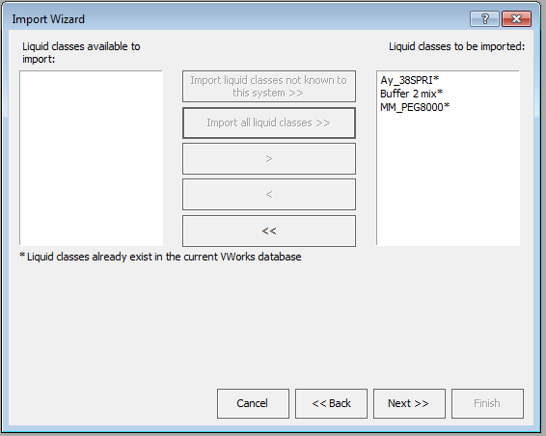

1. **Extremely important!** Device profiles 🡪 Import device profiles not known to this system. Be aware that you might have different teach points for each device. You may need to fine tune the teach points per Bravo profile.

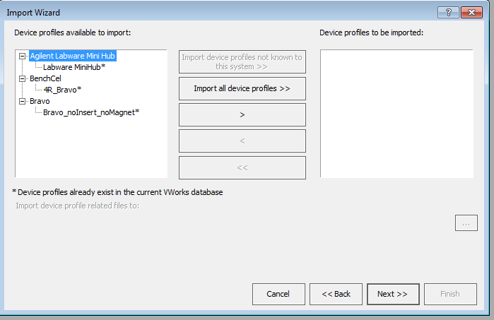

1. Next 🡪

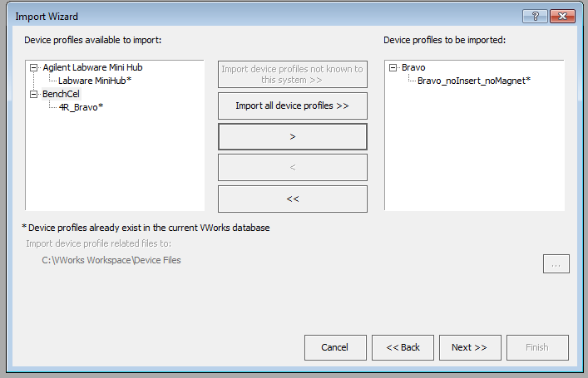

1. Error handlers. You do not have to import error handlers. 🡪 Next

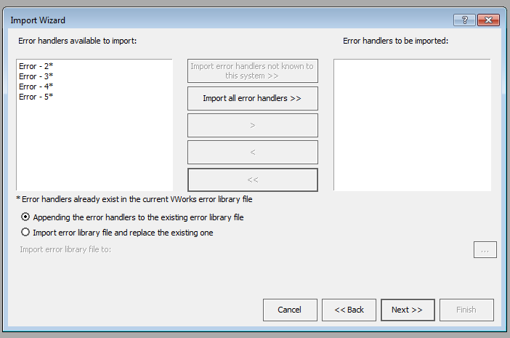

1. Double check the summary of the import files. 🡪 Finish!

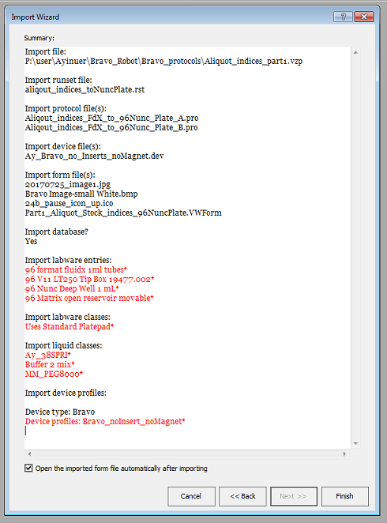

1. The summary of the import files part2:

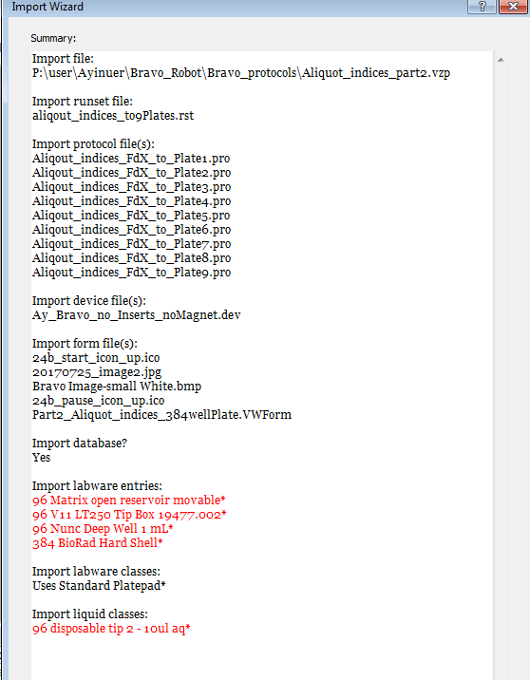

1. Once the import wizard completes, the Form file will pop up. Go to Tools select Edit Form as pictured below:

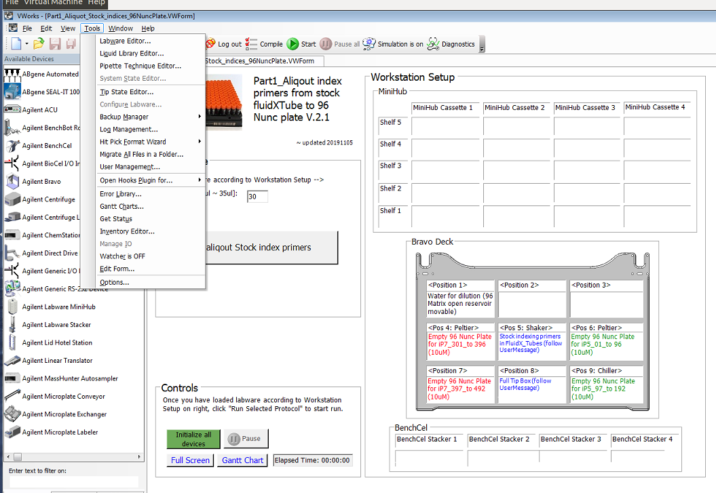

1. If you click the “Start aliquot stock index primers”, you will see the path to the Runset file. You must provide the correct location of the Runset file of Part 1!

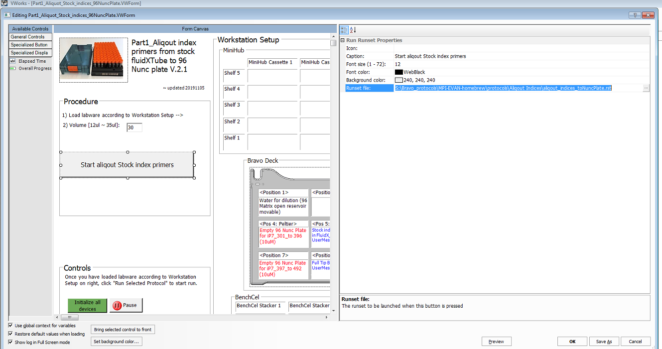

1. If you click the “Start aliquot index primers”, you will see the path to the Runset file. You must provide the correct location of the Runset file of Part2!

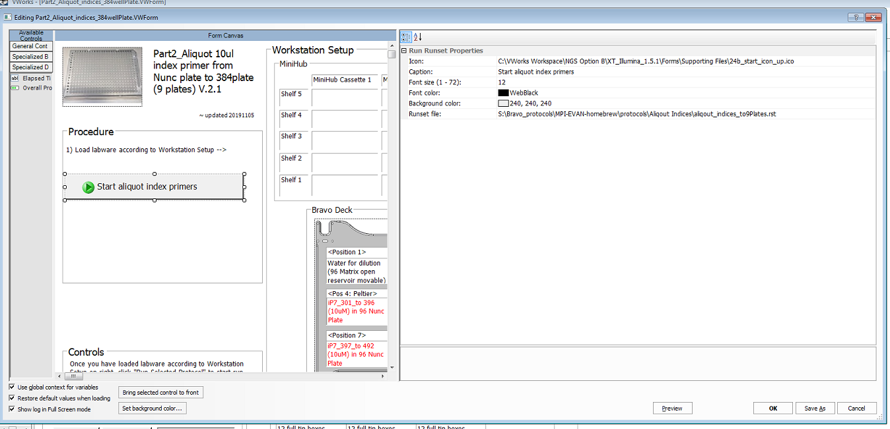

1. If you click “initialize all devices”, you will see the path to the Device file. You must provide the correct location of the device file!

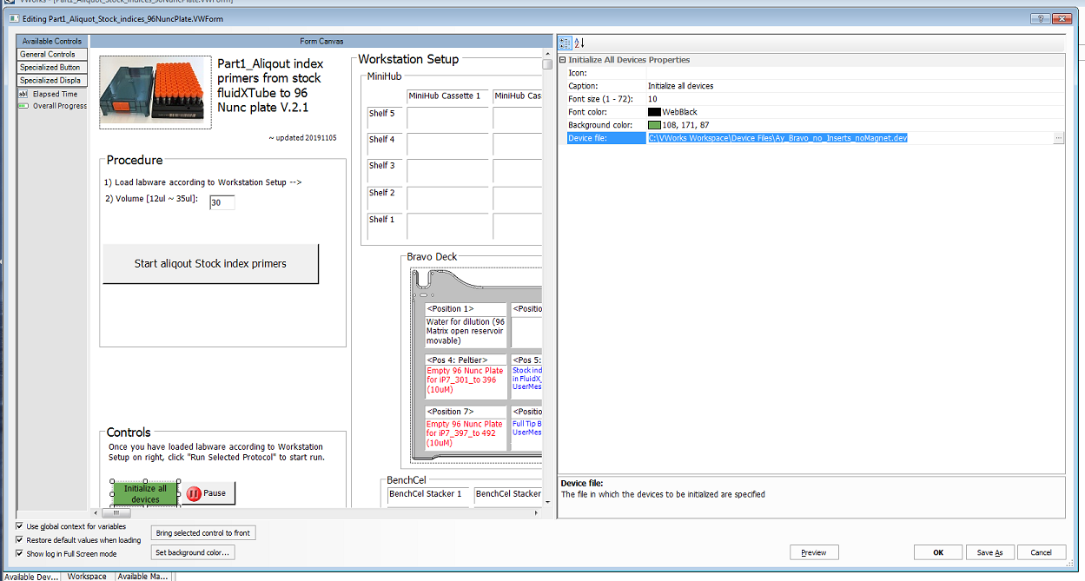

1. Once you are done with importing the files successfully, you may try to initialize all devices. If the orbital shaker of your device has different serial port number than the imported device profile file, you can adjust it easily in the registry editor as attached picture below.



## 4. How to import 96_ssDNAprep_indexingPCR_setup protocol files

**Files needed:**

1. VWork software version 13.1.0.1366
2. Device file: Bravo6-384-Insert.dev
3. Bravo device profile is: Bravo6-384-Insert
4. Form file: 96_ssDNAprep_indexingPCR.VWForm

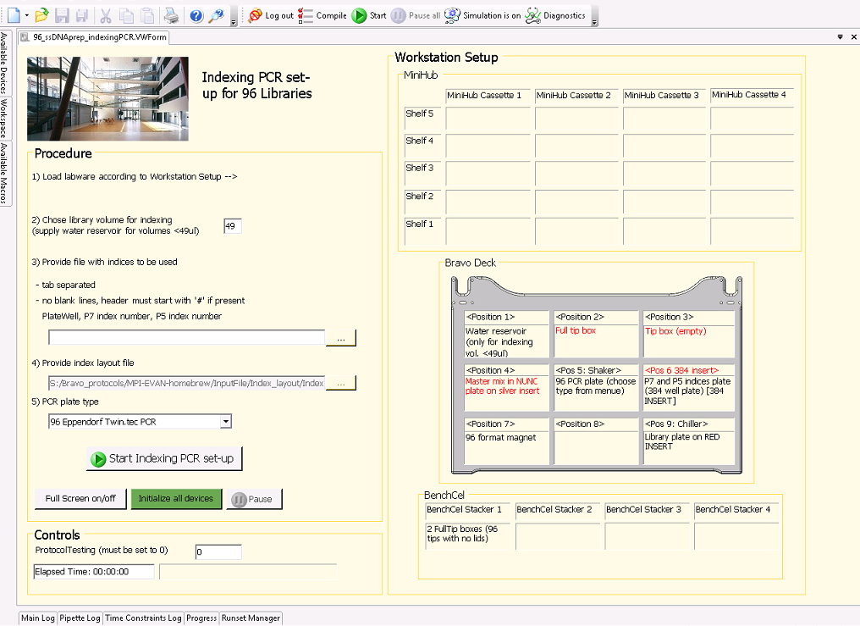

1. Protocol file: ssDNAprep_96samples_X_indexing-PCR.pro
2. Labware editor:

* 96 Ay Deep-well HTS reservoir
* 96 V11 LT250 Tip Box 19477.002
* 96 Nunc Deep Well 1 mL using Silver Insert
* 96 Eppendorf Twin.tec PCR in Red Alum Insert
* 96 Eppendorf twin.tec semi-skirted PCR in Red Alum Insert
* 384 BioRad Hard Shell
* 384 Ay BioRad Hard Shell clear wells

1. Liquid classes:

* 96 disposable tip 2 - 10ul aq
* 96 disposable tip 50 - 180ul aq
* 96 disposable tip 2 - 50ul
* 96 disposable tip 10 - 50ul aq

**Procedure:**

1. Start the VWorks software and login as administrator. Navigate to the File tab and click Import:



1. It is advisable to save a backup before importing anything by selecting 🡪 Yes



1. Select the file to import: 96_ssDNAprep_indexingPCR_setup.vzp and select the desired location for device files and protocol files as well as for the runset files. 🡪 Next

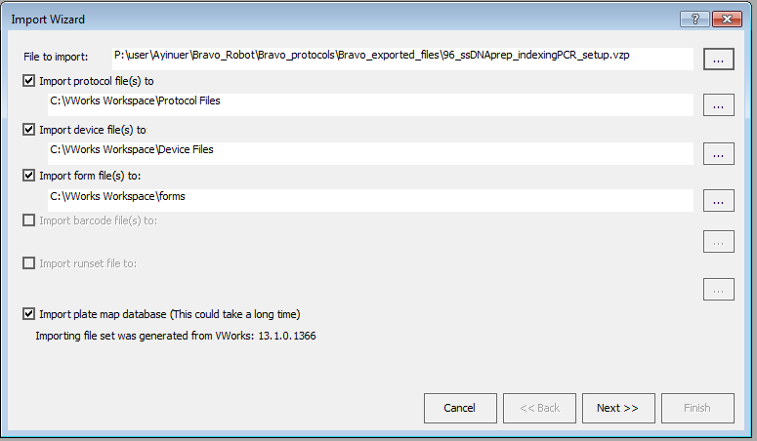

1. Confirm the final location for each file type. 🡪 OK

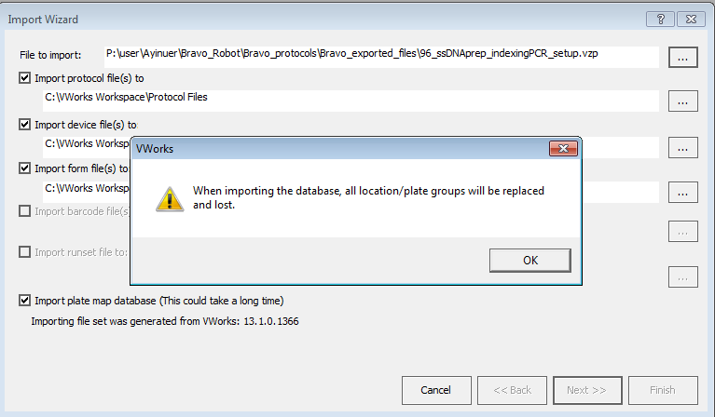

1. Below is the list of customer labware entries. 🡪 Import labware entries not known to this system **>>**.

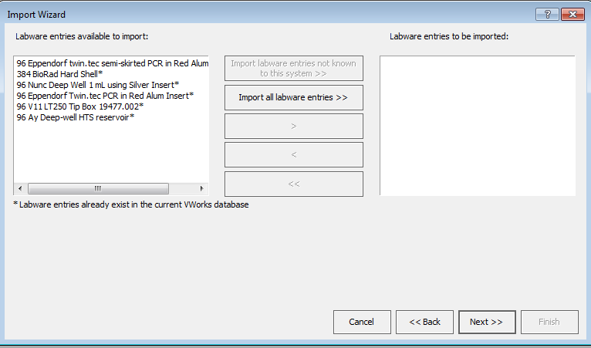

1. Next 🡪

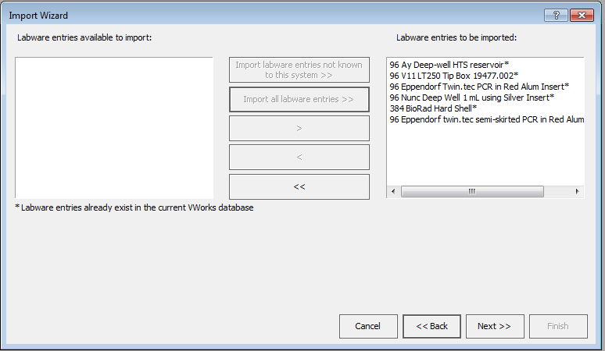

1. Next 🡪



1. Check continue and append new labware entries to the labware class – The labware class will contain both new and existing labware entries. 🡪 OK



1. Below is the list of customer liquid classes. 🡪 Import liquid classes not known to this system **>>**.

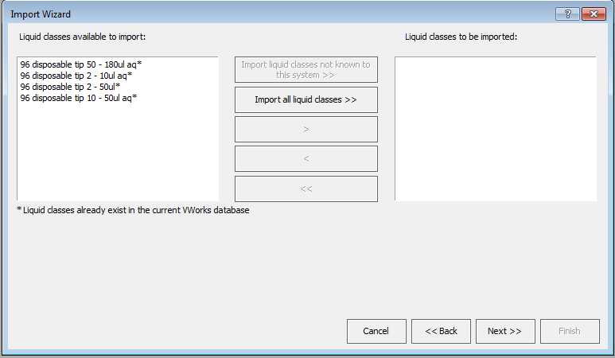

1. Next

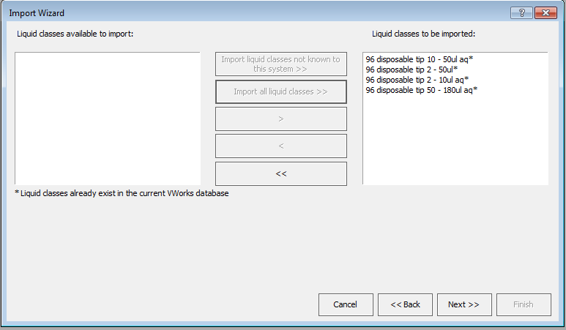

1. **Extremely important!** Device profiles 🡪 Import device profiles not known to this system. Be aware that you might have different teach points for each device. You may need to fine tune the teach points per Bravo profile.

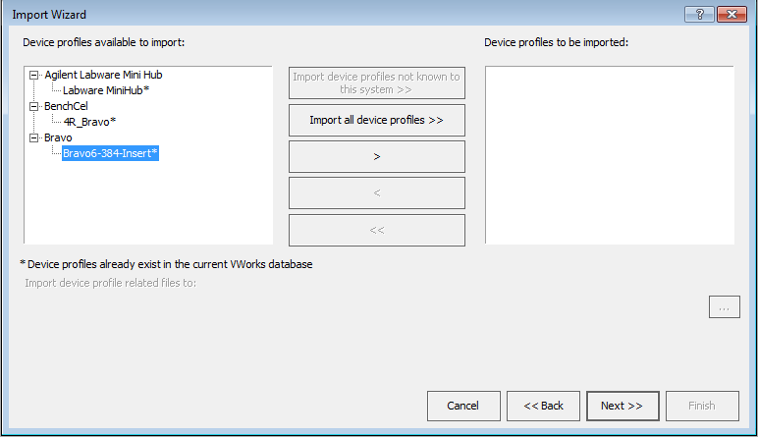

1. Next 🡪

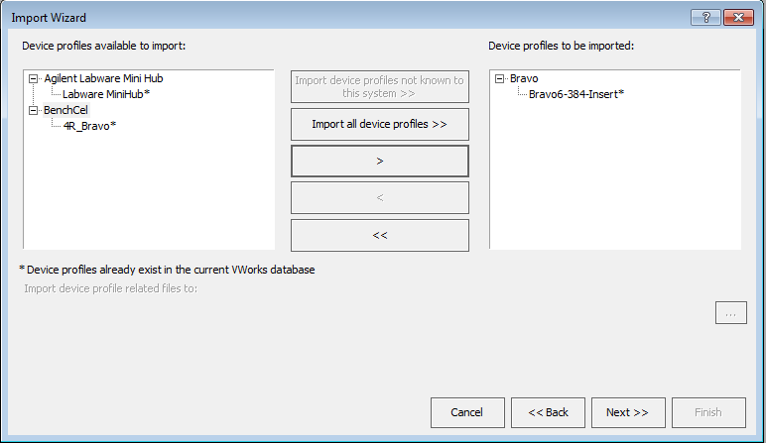

1. Error handlers. You do not have to import error handlers. 🡪 Next

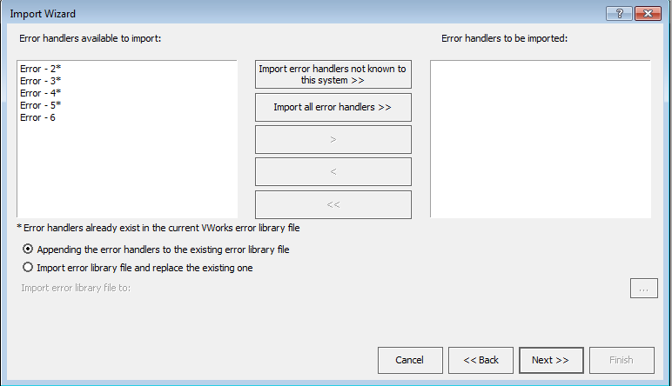

1. Indexing layout file 🡪

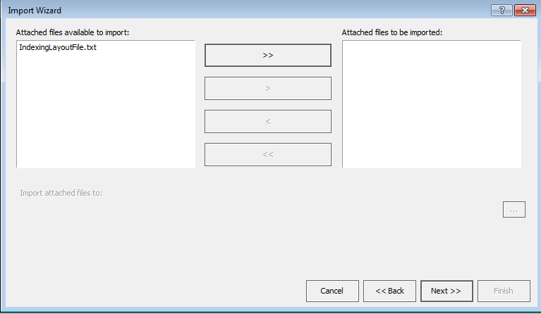

1. Create a folder for attached file in C:\VWorks Workspace\VWorks. Import location for Indexing layout file should be changed in the Form file. 🡪 Next

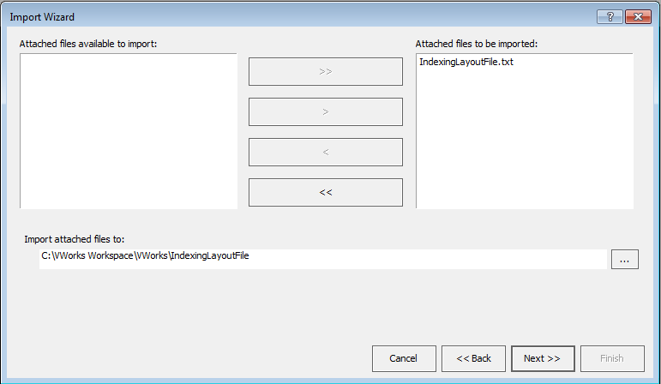

1. Double check the summary of the import files. 🡪 Finish!

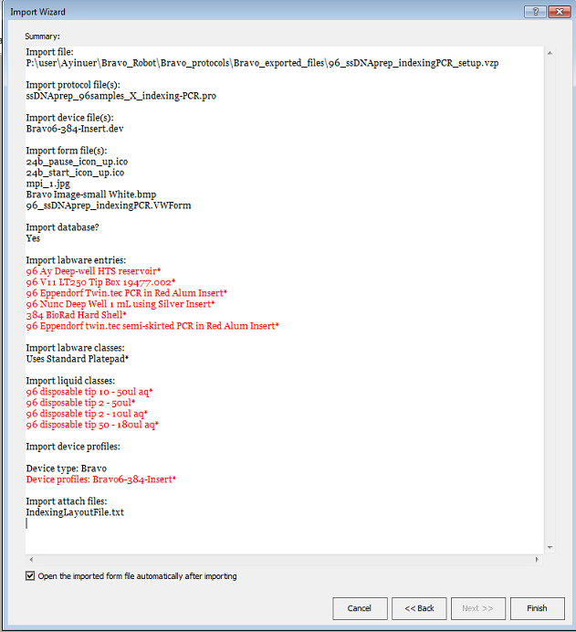

1. Once the import wizard completes, the Form file will pop up. Go to Tools select Edit Form as pictured below:

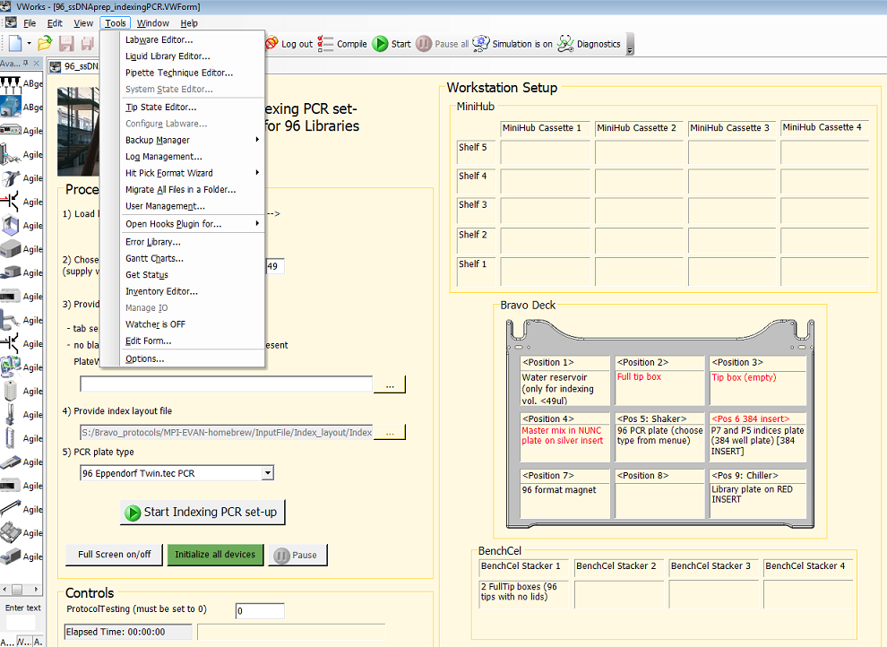

1. If you click the “Start Indexing PCR set-up”, you will see the path to the Protocol file. You must provide the correct location of the Protocol file!

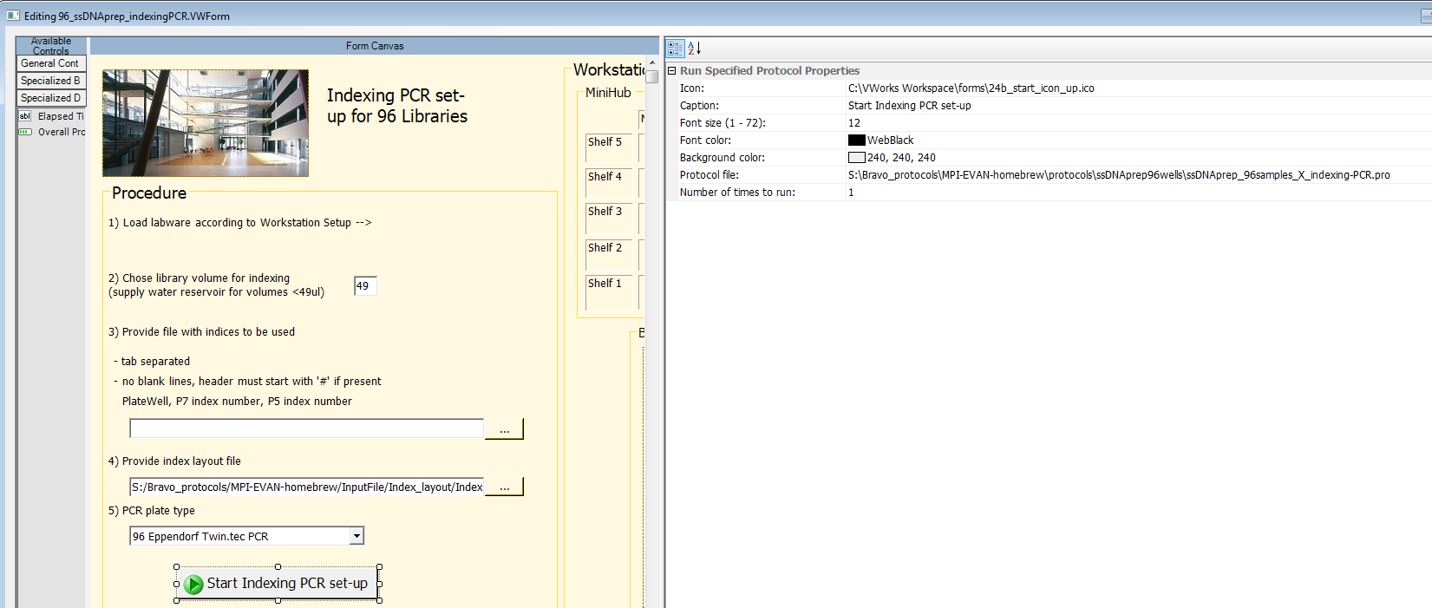

1. If you click “initialize all devices”, you will see the path to the Device file. You must provide the correct location of the device file!

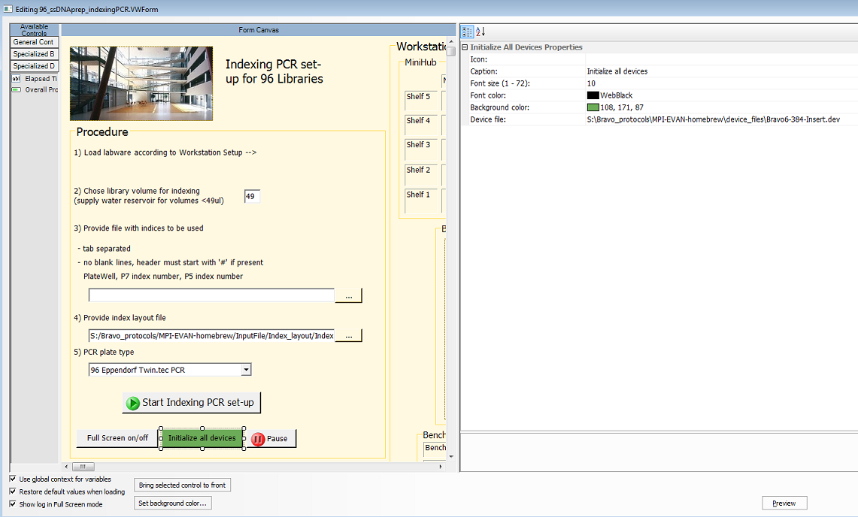

1. If you click below “Provide index layout file”, you will see the path to the Index layout file. You must provide the correct location of the layout file!

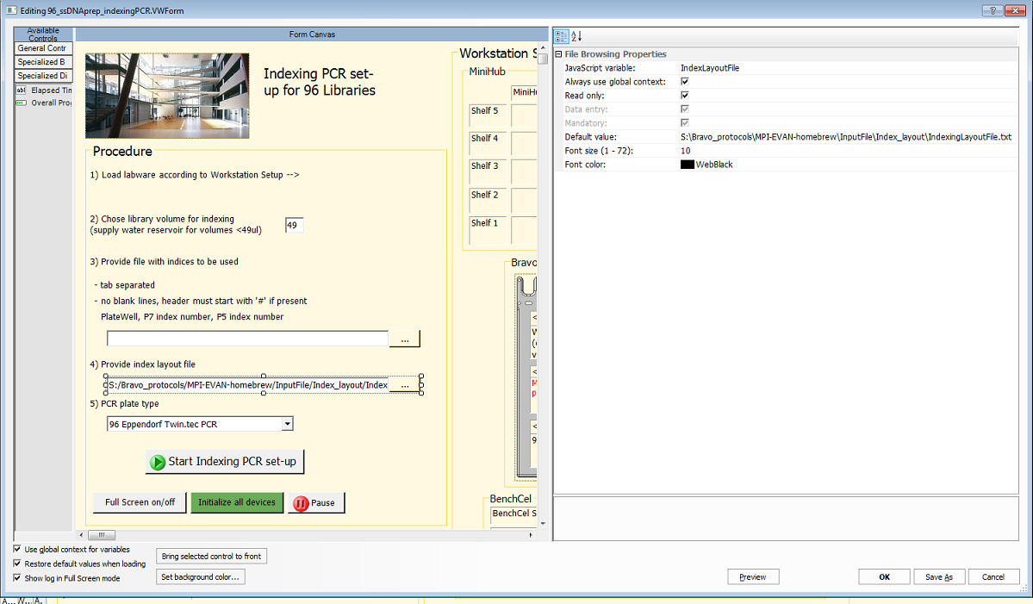

1. Once you are done with importing the files successfully, you may try to initialize all devices. If the orbital shaker of your device has different serial port number than the imported device profile file, you can adjust it easily in the registry editor as attached picture below.



## 5. How to import SPRI beads purification protocol files

### 5.1 Bravo 96 format 28% SPRI purification

**Files needed:**

1. VWork software version 13.1.0.1366
2. Device file: BravoMiniPHBenchCel_round_magnet.dev
3. Bravo device profile is: Bravo-Mag and Shaker
4. Form file: 96_SPRI_28_Purifications.VWForm

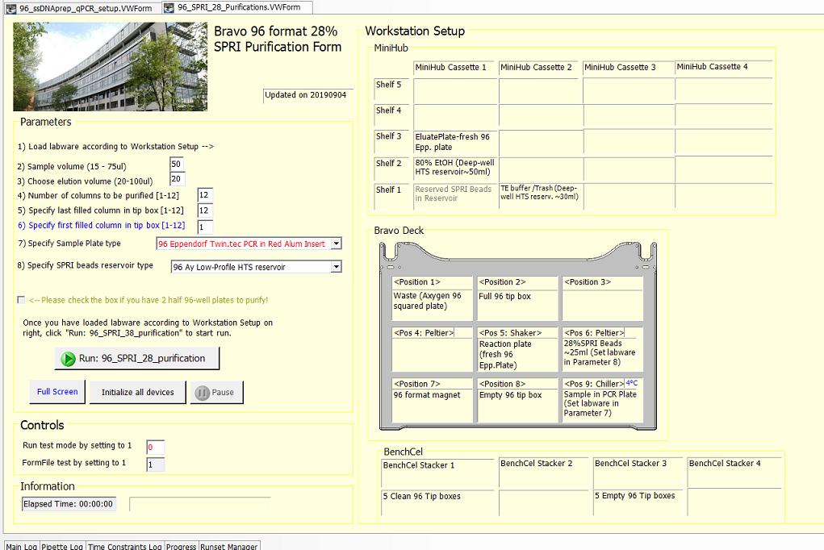

1. Protocol file: SPRI28_purification.pro
2. Labware editor:

* 96 Ay Deep-well HTS reservoir
* 96 V11 LT250 Tip Box 19477.002
* 96 Eppendorf Twin.tec PCR
* 96 Deep Well PP Sqr Well V Btm

1. Liquid classes:

* Ay_Ethanol to waste
* Ay_buffer
* Ay_longDisp
* Ay_Dispense
* Ay_dispenseWait1min
* Ay_dispenseWait3min
* Ay_slow aspirate
* Ay_38SPRI
* Ay_38SPRImixing1

**Procedure:**

1. Start the VWorks software and login as administrator. Navigate to the File tab and click Import:



1. It is advisable to save a backup before importing anything by selecting 🡪 Yes



1. Select the file to import: 96_ssDNAprep_SPRI_Purification.vzp and select the desired location for device files and protocol files as well as for the runset files. 🡪 Next

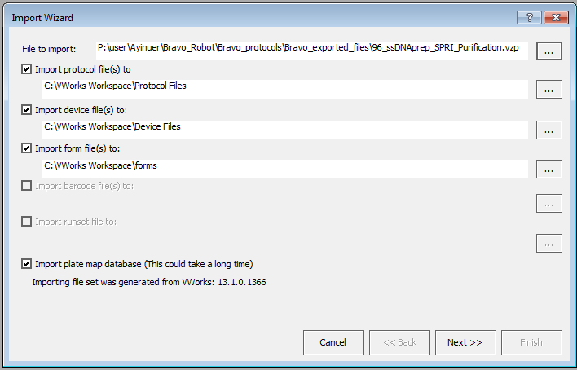

1. Confirm the final location for each file type. 🡪 OK

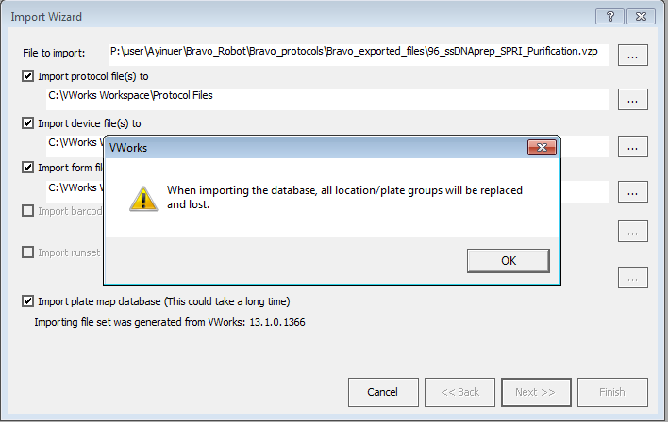

1. Below is the list of customer labware entries. 🡪 Import labware entries not known to this system **>>**.

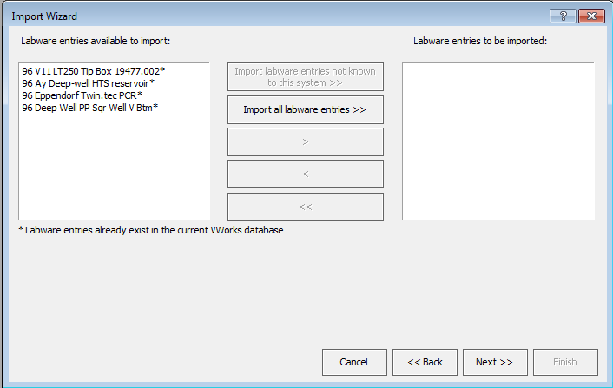

1. Next 🡪

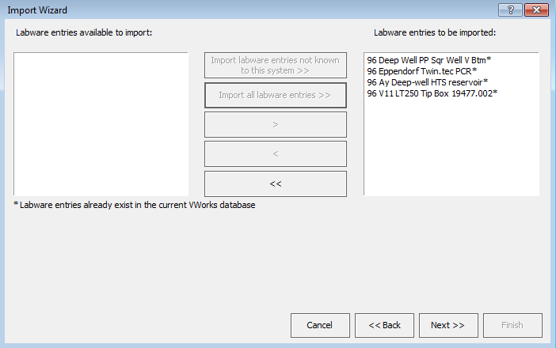

1. Next 🡪



1. Check continue and append new labware entries to the labware class – The labware class will contain both new and existing labware entries. 🡪 OK



1. Below is the list of customer liquid classes. 🡪 Import liquid classes not known to this system **>>**.

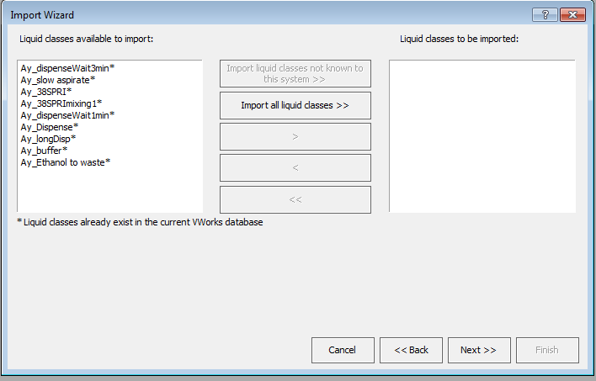

1. Next

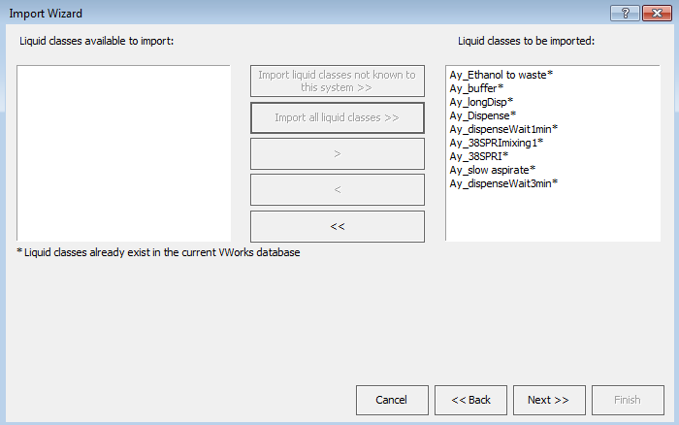

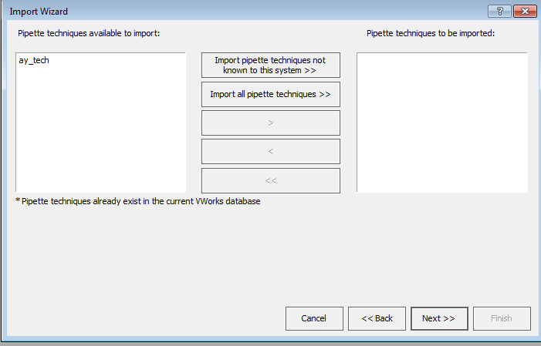

1. **Extremely important!** Device profiles 🡪 Import device profiles not known to this system. Be aware that you might have different teach points for each device. You may need to fine tune the teach points per Bravo profile.

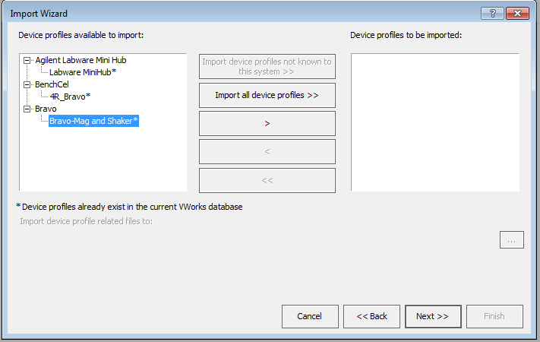

1. Next 🡪

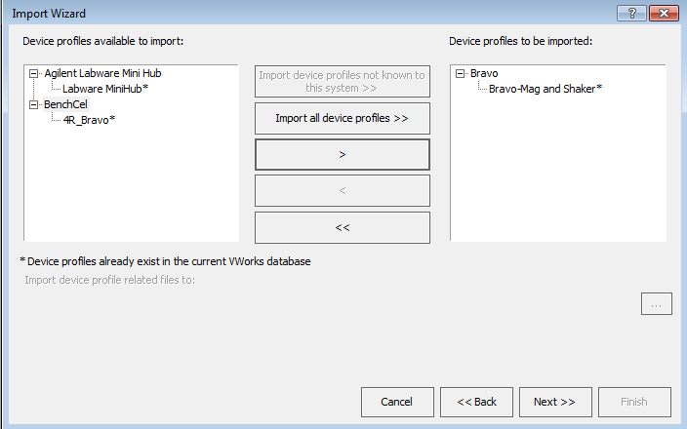

1. Error handlers. You do not have to import error handlers. 🡪 Next



1. Attached files for pipette techniques click **>>** then 🡪 Next

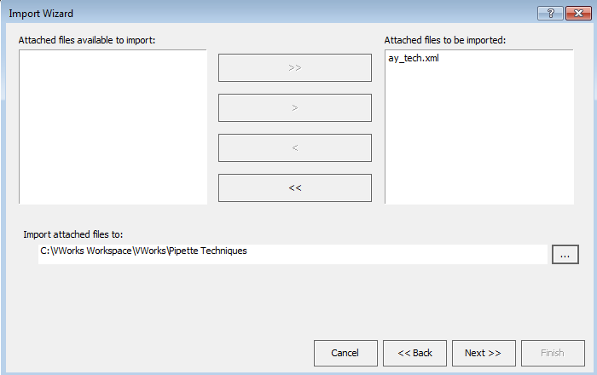

1. Double check the summary of the import files. 🡪 Finish!

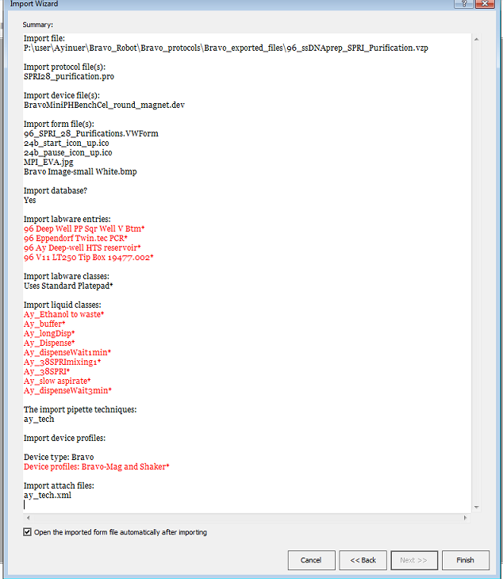

1. Once the import wizard completes, the Form file will pop up. Go to Tools select Edit Form as pictured below:

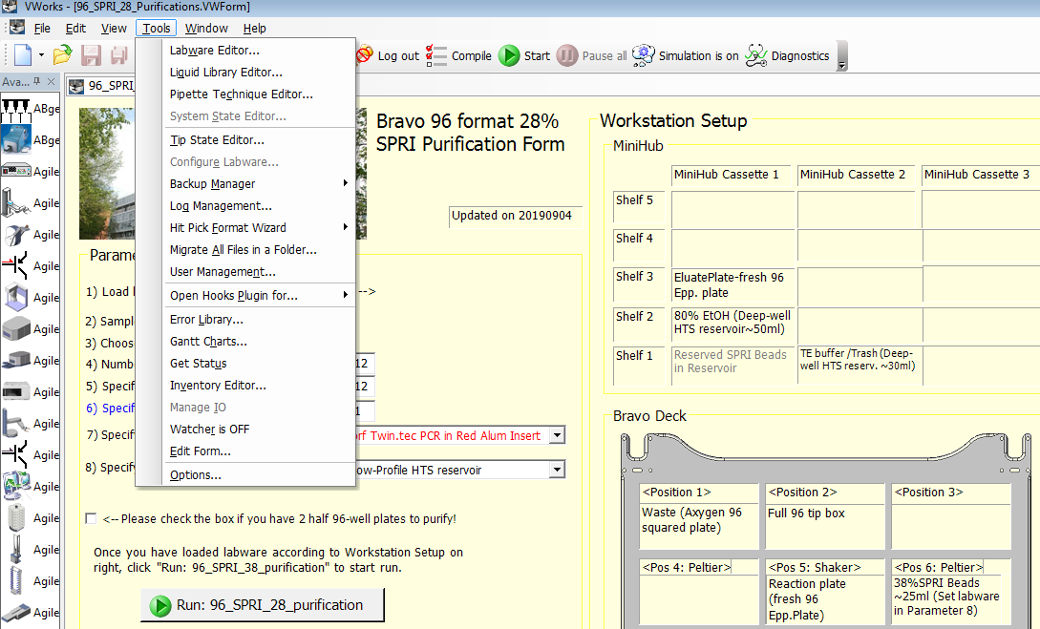

1. If you click the “Run: 96_SPRI_28_purification”, you will see the path to the Protocol file. You must provide the correct location of the Protocol file!

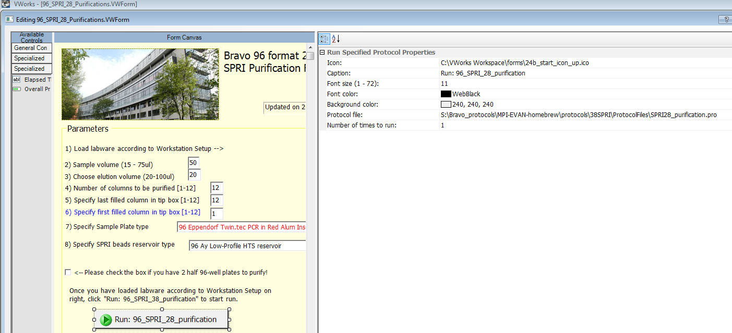

1. If you click “initialize all devices”, you will see the path to the Device file. You must provide the correct location of the device file!

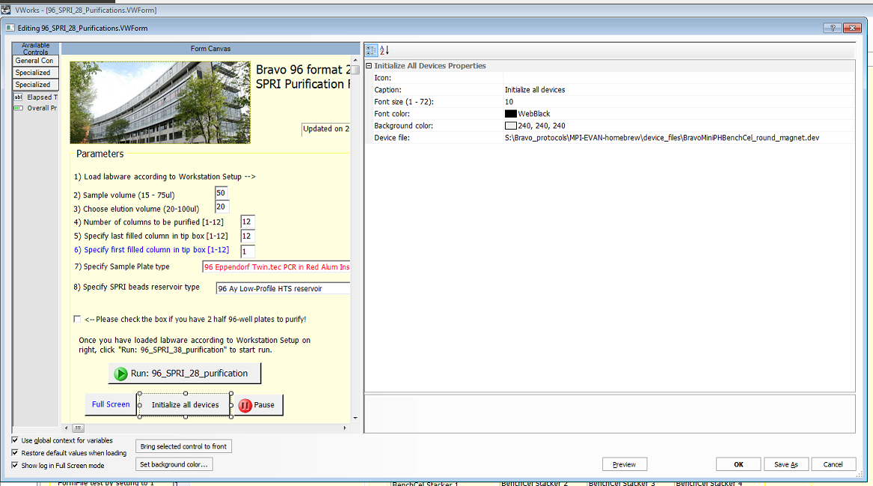

1. Once you are done with importing the files successfully, you may try to initialize all devices. If the orbital shaker of your device has different serial port number than the imported device profile file, you can adjust it easily in the registry editor as attached picture below.



### 5.2 Bravo 384 format 28% SPRI purification

**Files needed:**

1. VWork software version 13.1.0.1366
2. Device file:
3. Bravo device profile is:
4. Form file: 384_SPRI_28_Purifications.VWForm

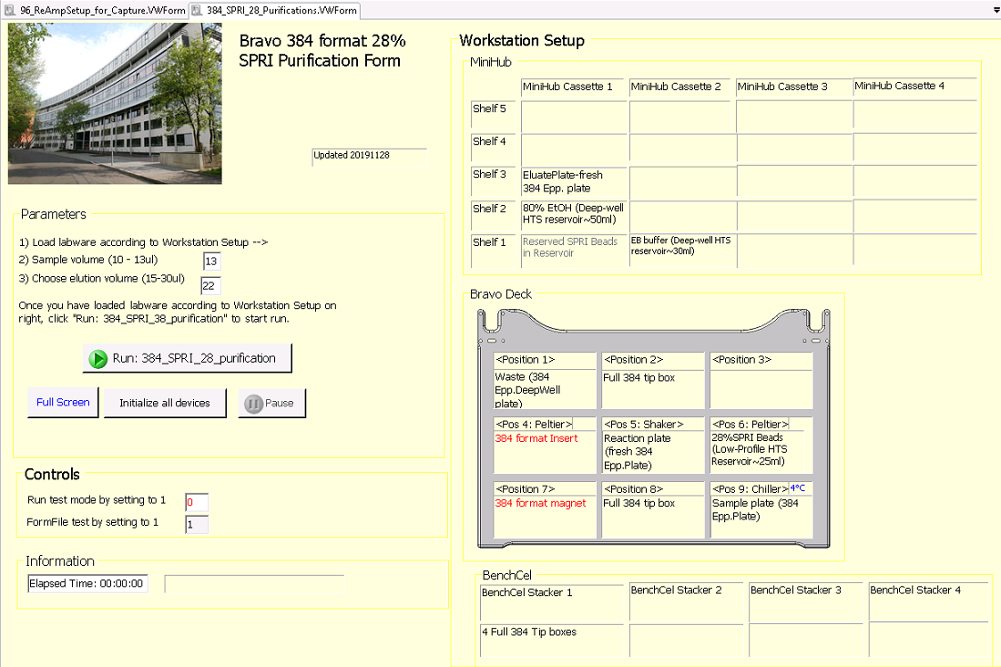

1. Protocol file:

## 6. How to import Capture setup protocols

### 6.1 Re amplification setup for capture of 96 libraries

**Files needed:**

1. VWork software version 13.1.0.1366
2. Device file:
3. Bravo device profile is:
4. Form file: 96_ReAmpSetup_for_Capure.VWForm

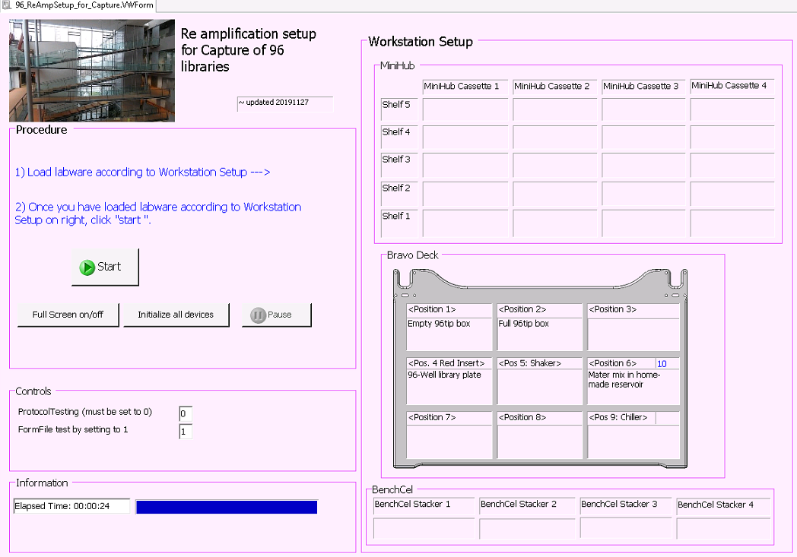

1. Protocol file:

### 6.2 Re amplification setup for capture of 384 libraries

**Files needed:**

1. VWork software version 13.1.0.1366
2. Device file:
3. Bravo device profile is:
4. Form file: 384_ReAmpSetup_for_Capure.VWForm

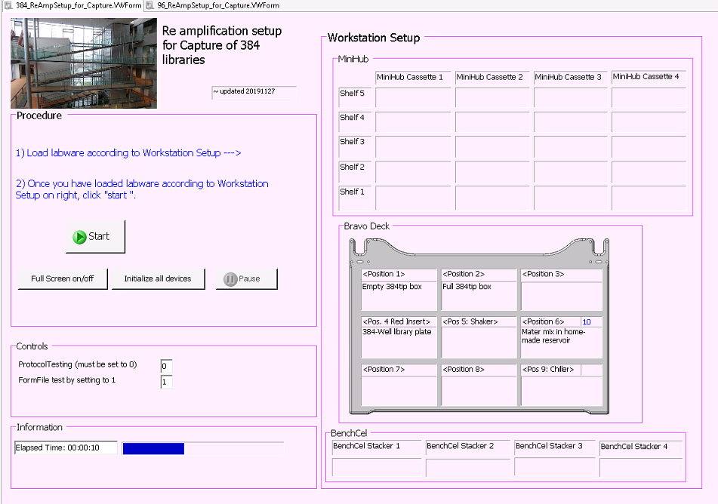

Protocol file:

### 6.3 Preparation for capture plate setup

#### 6.3.1 Transfer libraries from 96-well plate to 96-well plate

**Files needed:**

1. VWork software version 13.1.0.1366
2. Device file:
3. Bravo device profile is:
4. Form file:

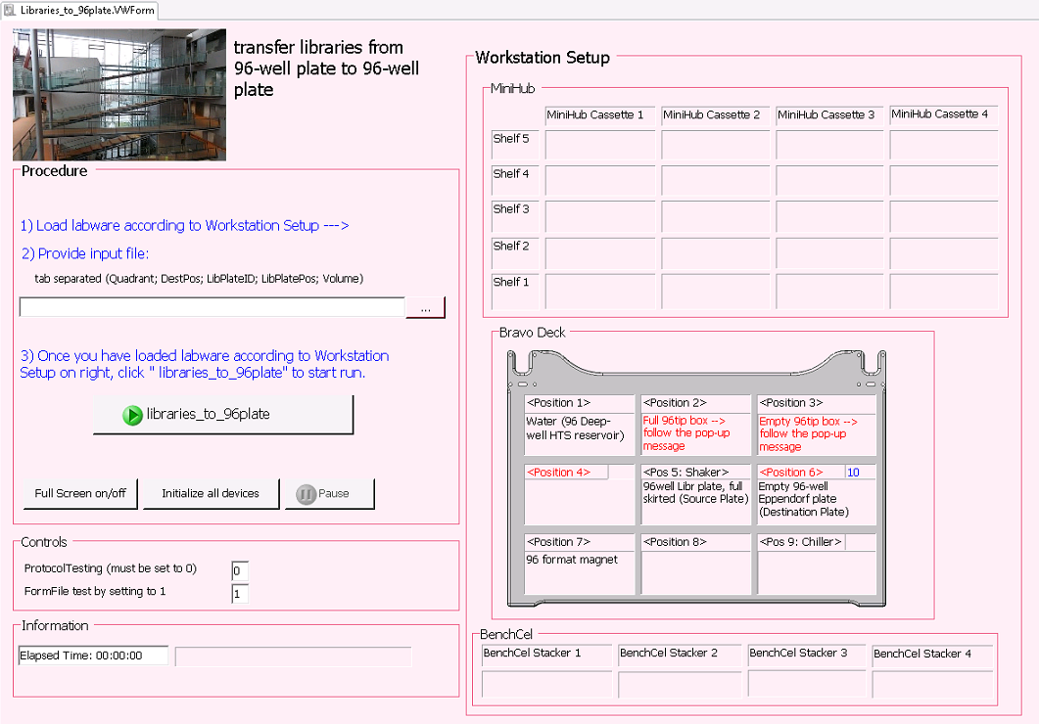

1. Protocol file:

#### 6.3.2 Transfer libraries from 96-well plate to 384-well plate

**Files needed:**

1. VWork software version 13.1.0.1366
2. Device file:
3. Bravo device profile is:
4. Form file: Libraries_to_384plate.VWForm

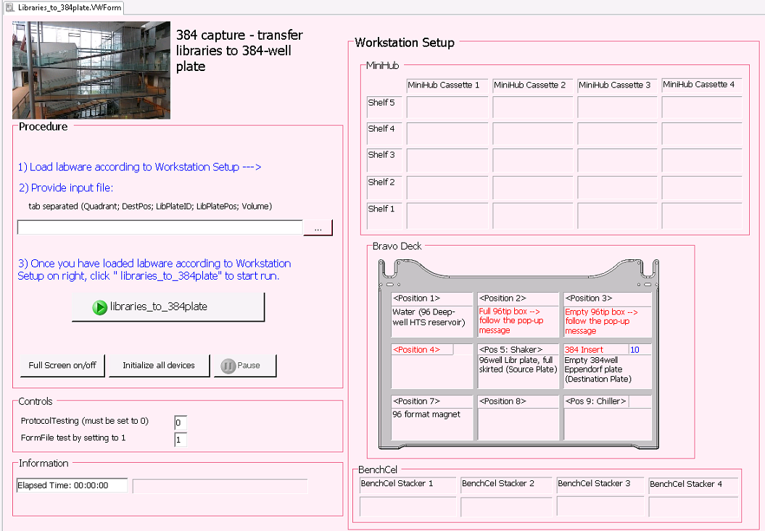

1. Protocol file:

#### 6.3.3 Transfer Baits from 5ml tubes to 384-well plate

**Files needed:**

1. VWork software version 13.1.0.1366
2. Device file:
3. Bravo device profile is:
4. Form file: Baits_to_384plate.VWForm

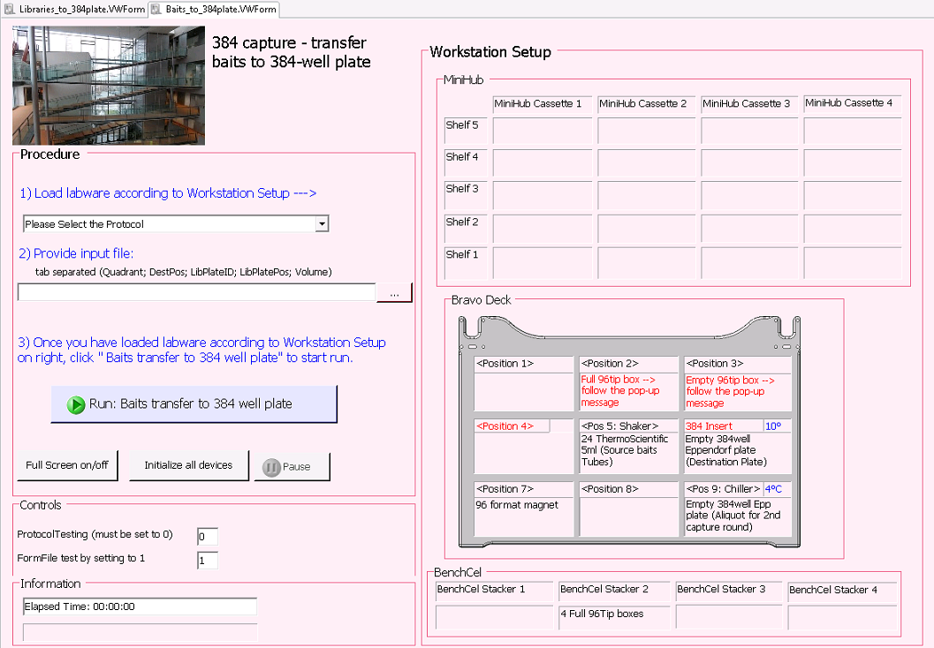

1. Protocol file:

### 6.4 In solution capture preparation

#### 6.4.1 In solution Hybridization setup for 96 samples

**Files needed:**

1. VWork software version 13.1.0.1366
2. Device file:
3. Bravo device profile is:
4. Form file:96_inSolution_HybridizationSetup.VWForm

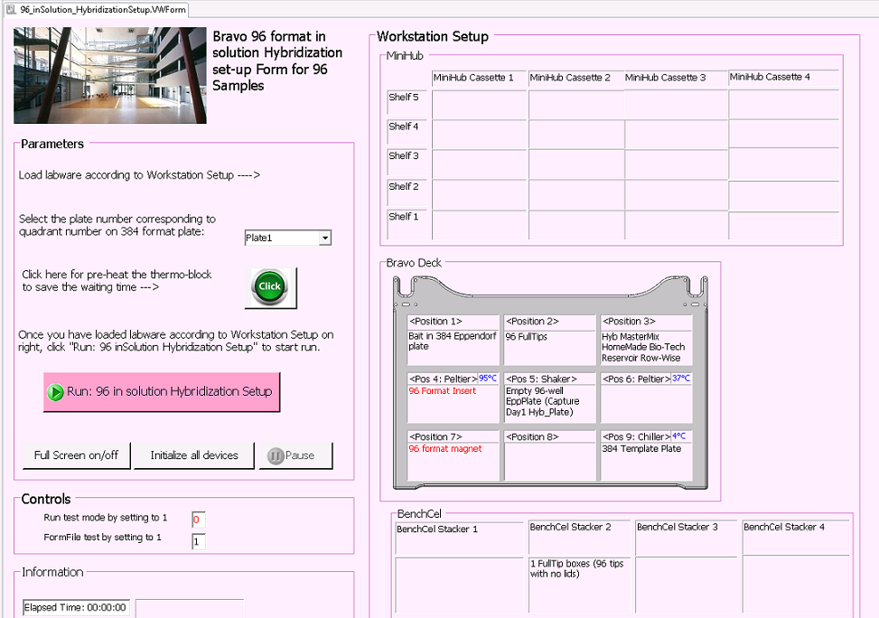

1. Protocol file:

#### 6.4.2 In solution capture clean-up for 96 samples

**Files needed:**

1. VWork software version 13.1.0.1366
2. Device file:
3. Bravo device profile is:
4. Form file:96_inSolution_CleanUp.VWForm

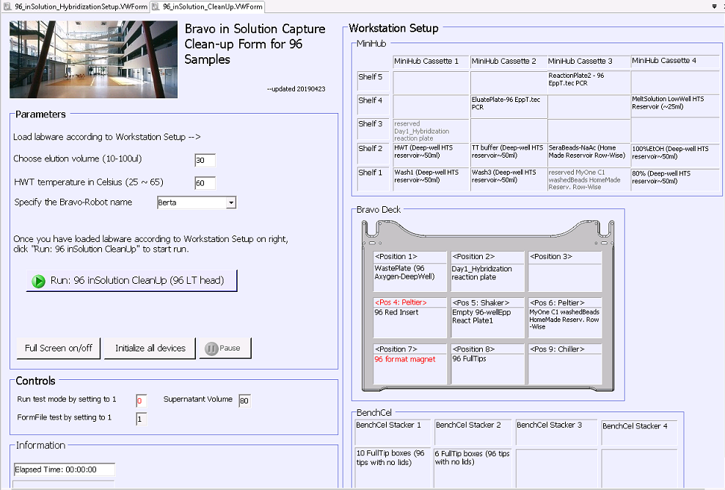

1. Protocol file:

#### 6.4.3 In solution Hybridization setup for 384 samples

This protocol is not yet existing

#### 6.4.4 In solution capture clean-up for 384 samples

##### 6.4.4.1 In solution capture clean-up for 384 samples using 96 LT head < Part 1>

**Files needed:**

1. VWork software version 13.1.0.1366
2. Device file:
3. Bravo device profile is:
4. Form file:384_inSolution_CleanUp_Part1.VWForm

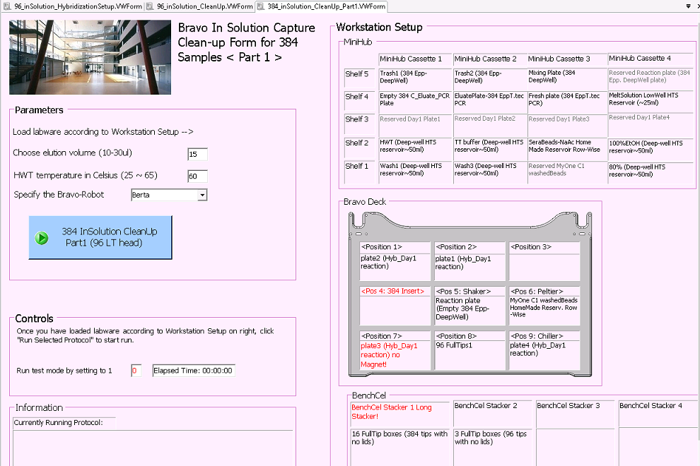

1. Protocol file:

##### 6.4.4.2 In solution capture clean-up for 384 samples using 384 ST head < Part 2>

1. VWork software version 13.1.0.1366
2. Device file:
3. Bravo device profile is:
4. Form file:384_inSolution_CleanUp_Part2.VWForm

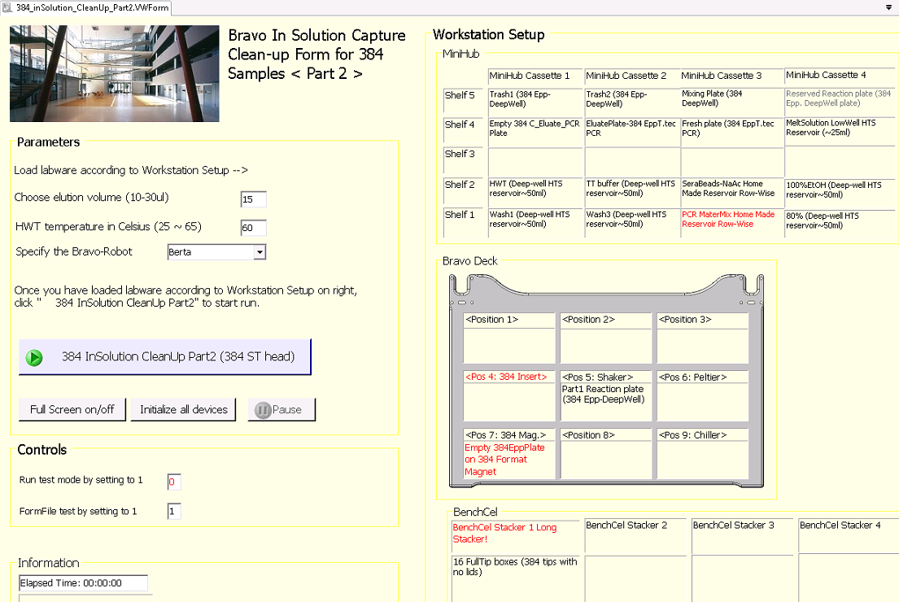

1. Protocol file:

### 6.5 On bead capture preparation

#### 6.5.1 On bead Hybridization setup for 96 samples

**Files needed:**

1. VWork software version 13.1.0.1366
2. Device file:
3. Bravo device profile is:
4. Form file:96_onBead_HybridizationSetup.VWForm

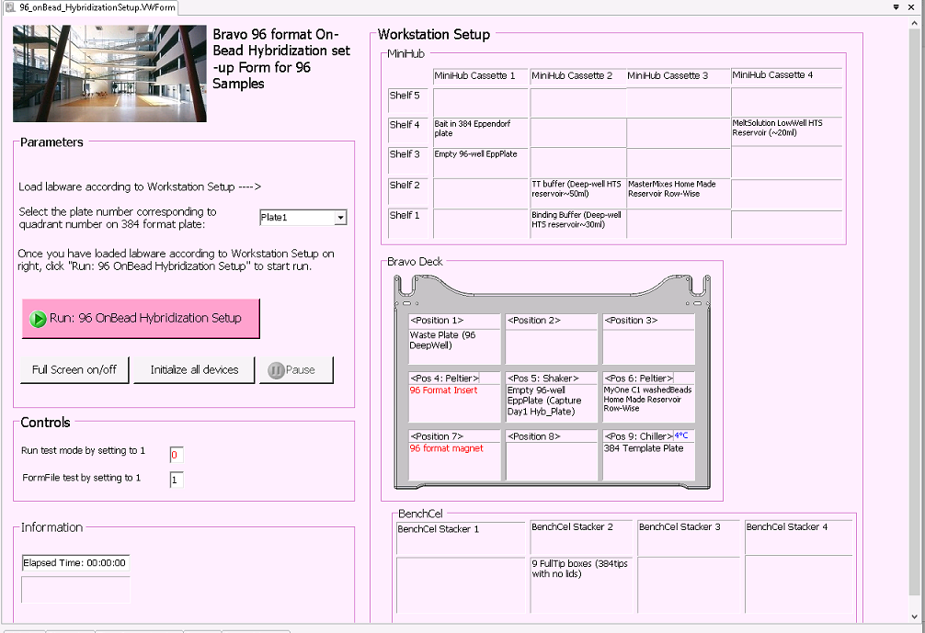

1. Protocol file:

#### 6.5.2 On bead capture clean-up for 96 samples

This protocol is not yet existing

#### 6.5.3 On bead Hybridization setup for 384 samples

**Files needed:**

1. VWork software version 13.1.0.1366
2. Device file:
3. Bravo device profile is:
4. Form file: 384_onBead_HybridizationSetup.VWForm

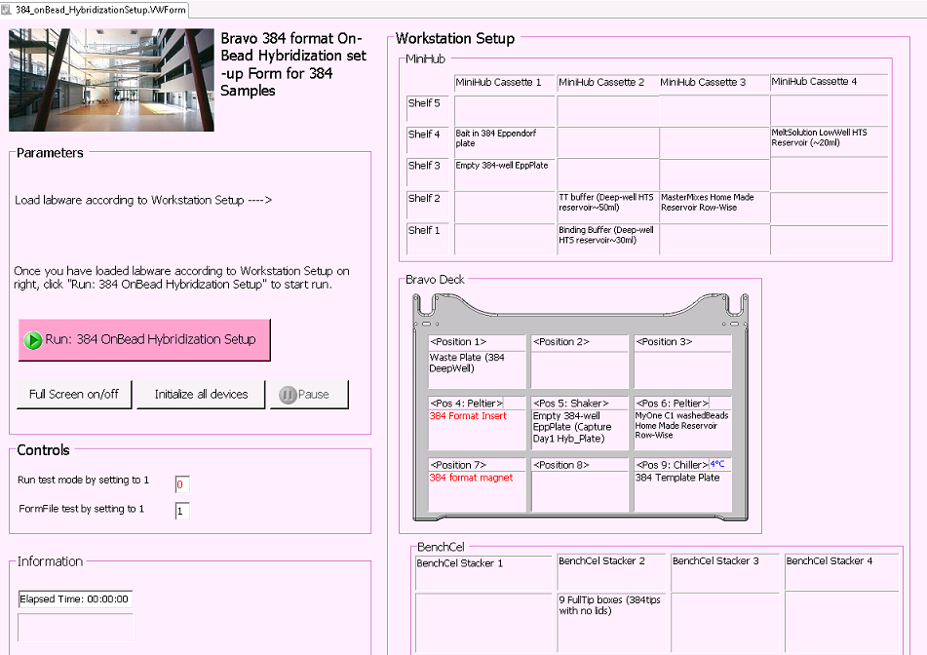

1. Protocol file:

#### 6.5.4 On bead capture clean-up for 384 samples

**Files needed:**

1. VWork software version 13.1.0.1366
2. Device file:
3. Bravo device profile is:
4. Form file: 384_onBead_CleanUp.VWForm

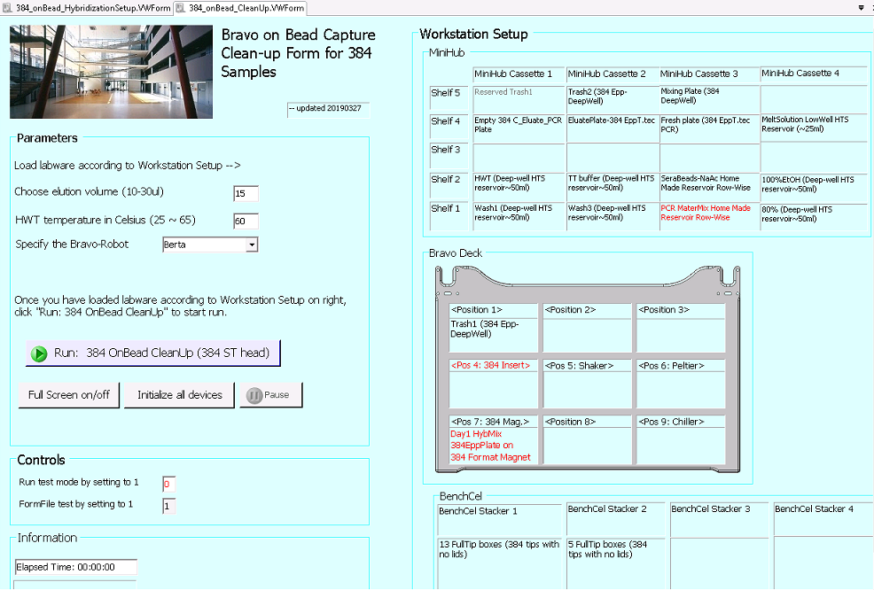

1. Protocol file:

### 6.6 Post capture preparation

#### 6.6.1 Libraries pool for sequencing preparation for 96 libraries

**Files needed:**

1. VWork software version 13.1.0.1366
2. Device file:
3. Bravo device profile is:
4. Form file: 96_library_pooling.VWForm

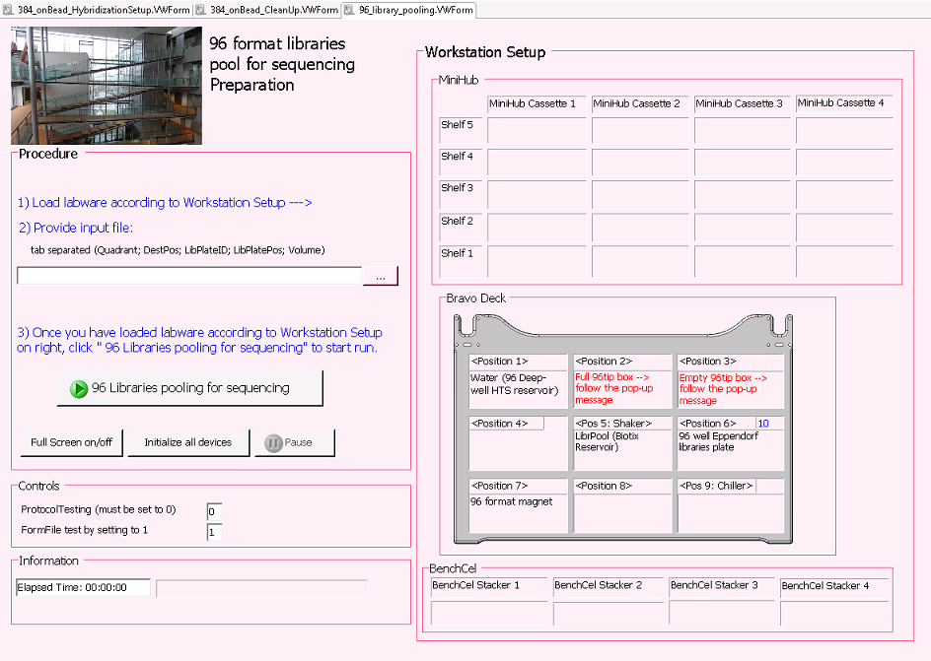

1. Protocol file:

#### 6.6.2 Libraries pool for sequencing preparation for 384 libraries

**Files needed:**

1. VWork software version 13.1.0.1366
2. Device file:
3. Bravo device profile is:
4. Form file: 384_library_pooling.VWForm

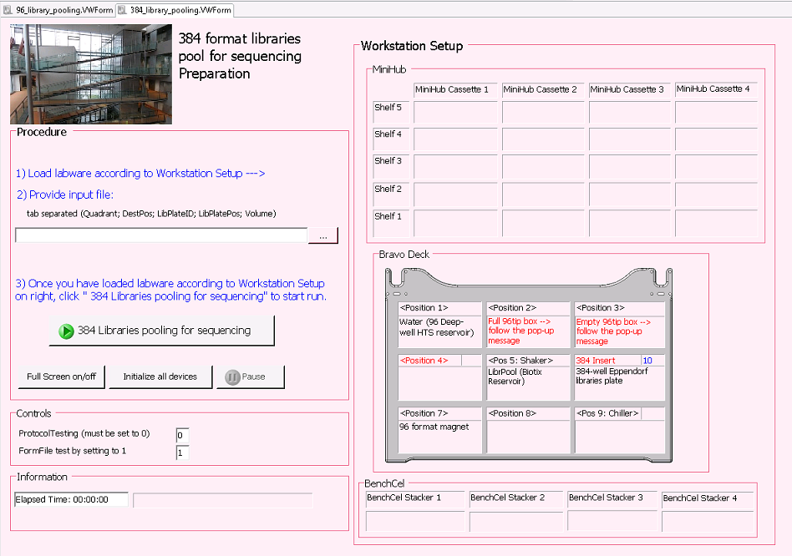

1. Protocol file:

7.

